|  |  |
| --- | --- |
| **Program Book** | **Short Term Internship** |

**AP STATE COUNCIL OF HIGHER EDUCATION**

(A STATUTORY BODY OF GOVERNMENT OF ANDHRA PRADESH)

An Internship Report on

**ART SHOWCASE WEBSITE**

*Submitting an internship report as a part of academic requirement*

**of**

**BACHELOR OF TECHNOLOGY**

**in**

**COMPUTER SCIENCE AND ENGINEERING**

Submitted By

**B. CHITHAITHGARI SWETHA**

**(203N1A0503)**

**Under the esteemed guidance of Mis.**

**K.Rubiya Alam, Mtech.,**

**Assistant Professor**

**CSE Department**



#### DEPARTMENT OF COMPUTER SCIENCE AND ENGINEERING

**P.V.K.K. Institute of Technology**

(Approved by AICTE, New Delhi & Affiliated to JNTUA, Anantapuram) Sanapa Road, Rudrampeta, Anantapuram – 515001

**Andhra Pradesh 2023-2024**

**P.V.K.K INSTITUTE OF TECHNOLOGY**

**(Approved by AICTE, New Delhi & Affiliated to JNTUA, Anantapuram) Sanapa Road, Rudrampeta, Anantapuram – 515001**

#### DEPARTMENT OF COMPUTER SCIENCE AND ENGINEERING



**CERTIFICATE**

This is to certify that the Internship report entitled “**ART SHOWCASE WEBSITE**” is being submitted by **B. Chithaithgari Swetha** Reg. No: **203N1A0503.** In partial fulfillment of the requirements for the award of **B. TECH** in CSE in the P.V.K.K Institute of Technology, Anantapur. The Internship report is a bonafide work carried out by then under **Villindha Technologies Pvt Ltd** during the academic year 2023-2024.

Signature of Supervisor Signature of H.O.D

Mrs. K.Rubiya Alam, MTech., Dr. K. Bhargavi, MTech, Ph D.,

Assistant Professor Associate Professor & H.O.D

Dept. of CSE Dept. of CSE

#### DECLARATION

I, B.Chithaithgari Swetha(203N1A0503), hereby declare that this Internship report titled “Art Showcase Website” has been written by me. The work carried out is original and has not been submitted to any other University or Institution for the award of any credits.

###### Place: Date:

**ACKNOWLEDGEMENT**

At the outset, we thank our Honorable Founder, Correspondent & Secretary **Dr. Palle Raghunatha Reddy garu** M. Sc, M. Pill, Ph. D, Honorable Chairman, **Dr. Palle Venkata Krishna Kishore Reddy** B. Tech, M. Tech, MS(USA)., AMIE., (PhD) garu, and our Treasure **Smt. P. Sindhura Reddy** M. Tech, of Sri Balaji Educational Society for providing us with good faculty, the required equipment and their moral support.

We wish to express my sense of gratitude to **Dr. B. Ramesh Babu** B. Tech, M.S, Ph. D,

Principal, P.V.K.K Institute of Technology, Anantapur for providing necessary facilities.

With a great sense of pleasure, we extend our gratitude to **Dr. K. Bhargavi** M. Tech, Ph. D, Head of Computer Science & Engineering, for her co-operation and providing necessary help for completion of this project.

It is a great pleasure to express our heartful gratitude and thankfulness to my guide **Mrs. K.Rubiya Alam** M. Tech, Assistant Professor, Department of Computer Science & Engineering for his valuable guidance and helpful council rendered in the due course of the report.

Finally, we would like to thank one and all in the CSE department who helped us directly and indirectly along with our family members and friends for their cooperation to complete this project.

## An Internship Report On

**(Event Networking App)**

*Submitted in accordance with the requirement for the degree of B. Tech Program*

1. Name of the college : PVKKIT, Anantapur
2. Department : CSE
3. Name of the Faculty Guide : Mrs. K.Rubiya Alam
4. Duration of the INTERNSHIP : From 2nd May To 24th June,2023
5. Name of the Student & Roll No : B.Chithaithgari Swetha & 203N1A0503
6. Programme of Study : B. Tech
7. Year of Study : 4th Year
8. Date of Submission : 14th September,2023

## STUDENT’S DECLARATION

I, B.Chithaithgari Swetha, a student of B.TechProgram,Reg.No.203N1A0503of the Department of CSE, PVKK Institute of Technology, Anantapur do hereby declare that I have completed the mandatory internship from 2nd May 2023 To 24th June 2023 in Villindha Technologies under the Faculty Guideship of Mrs. Manjula, Department of CSE, PVKK Institute of Technology.

(Signature and date)

**Endorsements**

Faculty Guide

Head of the Department

Principal

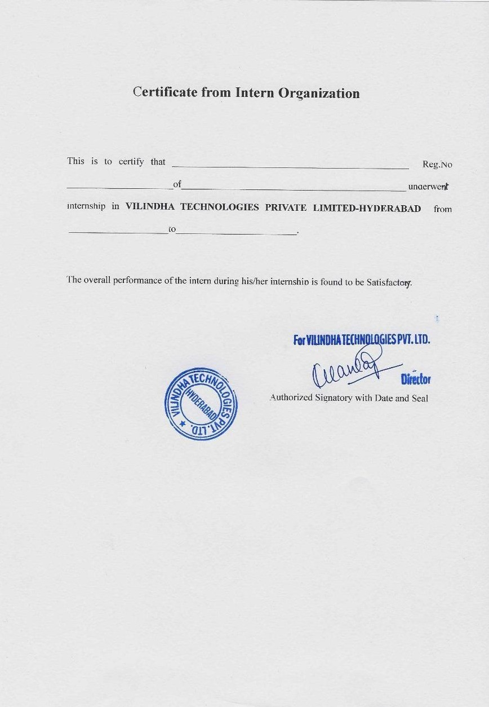

viii

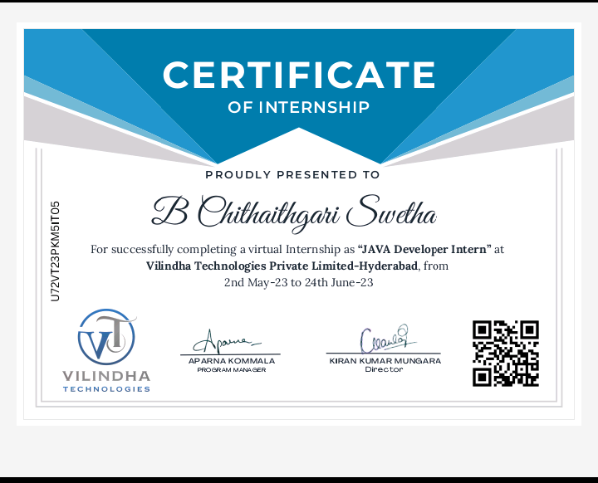

**INDEX**

|  |  |  |
| --- | --- | --- |
| **S. No** | **Contents** | **Page No** |
| **1** | **CHAPTER 1:** EXCLUSIVE SUMMARY | **1** |
| **2** | **CHAPTER 2:** OVERVIEW OF THE ORGANISATION | **2-4** |
| **3** | **CHAPTER 3:** INTERNSHIP PART | **5-7** |
| **4** | **CHAPTER 4:** ACTIVITY LOGS   * 4.1 Activity log for the first week * 4.2 Activity log for the second week * 4.3 Activity log for the third week * 4.4 Activity log for the fourth week * 4.5 Activity log for the fifth week * 4.6 Activity log for the sixth week | **8-20** |
| **5** | **CHAPTER 5:** OUTCOMES DESCRIPTION   * 5.1 Describe the work environment you have experienced * 5.2 Describe the real time technical skills you have acquired * 5.3 Describe the managerial skills you have acquired * 5.4 Describe how you could improve your communication skills * 5.5 Describe how could you could enhance your abilities in group discussions, participation in teams, contribution as a teammember, leading a team/activity. * 5.6 Describe the technological developments you have observedand relevant to the subject area of training | **21-32** |
| **6** | **CHAPTER 6:** CONCLUSION | **33** |
| **7** | **CHAPER 7:** ENDORSEMENTS OF STUDENT & SUPERVISOR | **34-37** |
| **8** | **CHAPTER 8:** PHOTOS & VIDEOS LINKS   * 8.1 Week-1: Photos & Videos Links * 8.2 Week-2: Photos & Videos Links * 8.3 Week-3: Photos & Videos Links * 8.4 Week-4: Photos & Videos Links * 8.5 Week-5: Photos & Videos Links * 8.6 Week-6: Photos & Videos Links | **38-43** |

### CHAPTER 1: EXCLUSIVE SUMMARY

The Java internship project revolved around the creation of a comprehensive "**Art Showcase Website**”. An event networking app is a mobile application designed to facilitate networking and communication among attendees at various events, such as conferences, trade shows, seminars, and social gatherings. These apps typically offer features that help attendees connect with each other, share information, and maximize their event experience. With a primary focus on Java programming, database integration, and user interface design, this internship project offered a hands-on experience in the realm of software development within the dynamic and innovative environment of Vilindha Technologies Pvt Ltd.

Here are five learning objectives for an internship report on Java Event Networking app:

* Learn the basics of Java programming.
* Understand the java programming.
* Acquire the knowledge of networking concepts, sockets and protocols.
* Learn how to use the Java Swing or JavaFX libraries.
* Learn the techniques for optimizing the app’s performance.

Here are few learning outcomes for an internship report on Java Event Networking App:

* Developed a responsive Java-based "Event Networking" app with real-time task management capabilities.
* Implemented an efficient database system to store and retrieve user tasks, enhancing data integrity.
* Enhanced user experience by creating an intuitive and visually appealing graphical interface using Java Swing or JavaFX libraries.
* Successfully delivered a fully functional "Event Networking" app, meeting project objectives and client expectations.

The internship was conducted in the technology sector, at a company that develops software applications. The intern organization is a small startup with a team of experienced engineers.

Intern's activities during the internship included:

* Working on a team to develop the Event Networking App.
* Learning about basics of programming, and object-oriented programming.
* Using Java frameworks and libraries.
* Deploying the Event Networking App to a production environment.

### CHAPTER 2: OVERVIEW OF THE ORGANISATION

##### Introduction of the Organization

“***Vilindha Technologies Pvt Ltd***” is a leading provider of technology training and software services in India. We are dedicated to empowering individuals and organizations to thrive in today's fast-paced digital landscape.

Our team of experts has years of experience in delivering innovative technology solutions that help our clients stay ahead of the curve. We offer a range of services, including technology training, internships, software development, academic services, staffing, mentorship programs, and digital transformation consulting.

* + **Company Overview:** Vilindha Technologies Pvt Ltd is a technology company based in Hyderabad, India. It is registered under the Companies Act with the ID U72900TG2022PTC169394. The company operates under the Goods and Services Tax (GST) with the registration number 36AAJCV1500G1ZM.
  + **Geographical Location:** The company is located in the district of Hyderabad, specifically in the Mandal of Hyderabad. The precise address is PLOT-30, SRI SRINIVASA COLONY, SAHEB NAGAR, HYDERABAD, 500070.
  + **Contact Information:** Vilindha Technologies Pvt Ltd can be reached at the phone number 9014431776 or through email at [info@vilindha.com](mailto:info@vilindha.com).

##### Vision, Mission, and Values of the Organization

* + **Vision**: Creating a future-ready workforce through our industry-leading technology training and software services.
  + **Mission**: Bridge the gap between young graduates and the latest trends in technology.
  + **Values**: We are committed to:
    - Excellence: We strive to provide the highest quality of training and services.
    - Innovation: We are always looking for new ways to improve our offerings.
    - Integrity: We are honest and transparent in our dealings with our clients and partners.
    - Collaboration: We work together to achieve common goals.
    - Passion: We are passionate about technology and its potential to change the world.

##### Policy of the Organization, in relation with the intern role

Vilindha Technologies Pvt Ltd is committed to providing its interns with a valuable learning experience. We offer a structured program that includes hands-on training, mentorship, and opportunities to work on real-world projects.

Our internship policy is designed to:

* + Provide interns with the skills and knowledge they need to succeed in the tech industry.
  + Give interns the opportunity to work on real-world projects and gain practical experience.
  + Provide interns with mentorship and support from experienced professionals.
  + Help interns build their network and connect with potential employers.

##### Organizational Structure

Vilindha Technologies Pvt Ltd is a hierarchical organization with a clear chain of command. The organization is divided into the following departments:

* + **Training**: Responsible for developing and delivering training programs.
  + **Software Development**: Responsible for developing and maintaining software applications.
  + **Academic Services**: Responsible for providing academic support to students and professionals.
  + **Staffing**: Responsible for recruiting and placing employees.
  + **Mentorship Programs**: Responsible for providing mentorship and career development support to employees.
  + **Digital Transformation Consulting**: Responsible for helping clients adopt new technologies and improve their business processes.

##### Roles and responsibilities of the employees in which the intern is placed

The roles and responsibilities of the employees in which the intern is placed will vary depending on the department and the specific project the intern is working on. However, some common roles and responsibilities include:

* + Conducting research and gathering data.
  + Developing and testing software applications.
  + Writing technical documentation.
  + Providing customer support.
  + Working on projects to improve the organization's processes.

##### Performance of the Organization in terms of turnover, profits, market reach and market value

Vilindha Technologies Pvt Ltd is a privately held company, so its financial information is not publicly available. However, the company has been growing rapidly in recent years, and it is considered to be a leader in the technology training and software services industry.

##### Future Plans of the Organization

Vilindha Technologies Pvt Ltd plans to continue to grow its business in the coming years. The organization plans to expand its training programs, software development capabilities, and academic services. The organization also plans to expand its market reach and increase its market value.

### CHAPTER 3: INTERNSHIP PART

As a Java developer intern working on a “**Art Shoecase Website**”, you will work remotely from home and use the Java Development Kit (JDK), Eclipse IDE, Git and GitHub, and other tools and libraries as needed. Your tasks will include designing and implementing the Event Networking App, writing unit tests, documenting the code, and collaborating with other developers. You will also acquire skills in Java programming, object-oriented programming, unit testing, version control, agile development, and collaboration.

An event networking application can have a variety of features to enhance the networking and overall event experience. Here are some common features.

1. User Profiles:

Users can create profiles with their personal and professional information, including a profile picture.

1. Event Listings:

Display upcoming events with details such as date, time, location, and agenda.

1. Registration: Users can register for events they're interested in attending.
2. Networking Tools:

Matchmaking: Use algorithms to suggest potential connections based on user profiles and interests.

Chat/Messaging: Allow users to send messages and connect with each other.

Virtual Business Cards: Exchange digital business cards for easy contact sharing. Video Calls: Facilitate video meetings or calls within the app.

1. Event Agenda: Provide an interactive schedule with session details and speaker information
2. Live Polls and Surveys: Engage attendees with real-time feedback and interaction during sessions.
3. Push Notifications: Send event updates, reminders, and networking suggestions.
4. Discussion Forums: Create discussion boards or forums for attendees to discuss topics related to the event.
5. Networking Games: Gamify the networking experience with challenges and rewards.
6. Exhibitor/Booth Listings: For trade shows or expos, list exhibitors and provide a virtual booth experience.

The intern is grateful for the opportunity to have participated in this internship and would like to thank their mentors and colleagues for their guidance and support. The intern will work remotely from their home or other location. They will have access to a computer with a good internet connection, as well as the necessary software and tools. The intern will also have access to the company's codebase and documentation.

The intern will work a standard 40- 50-hour week, Monday through Friday. They will be expected to be available during regular business hours, but they may also be required to work some evenings or weekends as needed.

The intern will use a computer with a good internet connection, as well as the following software and tools:

* + **Java IDE**: This is a software development environment that allows the intern to write, compile, and run Java code.
  + **Git**: This is a version control system that allows the intern to track changes to their code.
  + **Jira**: This is a project management tool that allows the intern to track their tasks and progress.
  + **Confluence**: This is a wiki tool that allows the intern to document their work.

The intern will be responsible for the following tasks:

* + **Learning the basics of Java programming:** This includes learning about variables, data types, operators, control flow statements, and functions.
  + **Developing a Event Networking App using Java:** This involves designing the application, writing the code, and testing the application.
  + **Using Java frameworks and libraries:** This includes using frameworks such as Spring Boot and Hibernate, and libraries such as Apache Commons and Google Guava.
  + **Deploying the Event Networking App to a production environment:** This involves configuring the application to run in a production environment, such as a cloud server.

The intern will acquire the following skills during the internship:

* + **Java programming skills:** The intern will gain a strong understanding of the Java programming language, including its syntax, semantics, and libraries.
  + **Object-oriented programming skills:** The intern will learn about object-oriented programming concepts such as classes, objects, inheritance, and polymorphism.
  + **Software development skills:** The intern will learn about the software development process, including requirements gathering, design, development, testing, and deployment.
  + **Teamwork skills:** The intern will have the opportunity to work with a team of engineers and learn how to collaborate effectively.
  + **Communication skills:** The intern will need to communicate effectively with their mentor, team members, and other stakeholders.
  + **Problem-solving skills:** The intern will need to be able to identify and solve problems as they arise.

In addition to the above, the following are some other key skills that the intern may acquire:

* + The ability to work independently and as part of a team.
  + The ability to learn new technologies quickly.
  + The ability to meet deadlines and work under pressure.
  + The ability to communicate effectively with both technical and non-technical audiences.

The internship will be a great opportunity for the intern to learn and grow their skills. They will be exposed to a real-world software development environment and will have the opportunity to work on a challenging project. The intern will also have the opportunity to network with experienced engineers and learn from their expertise.

ACTIVITY LOGS

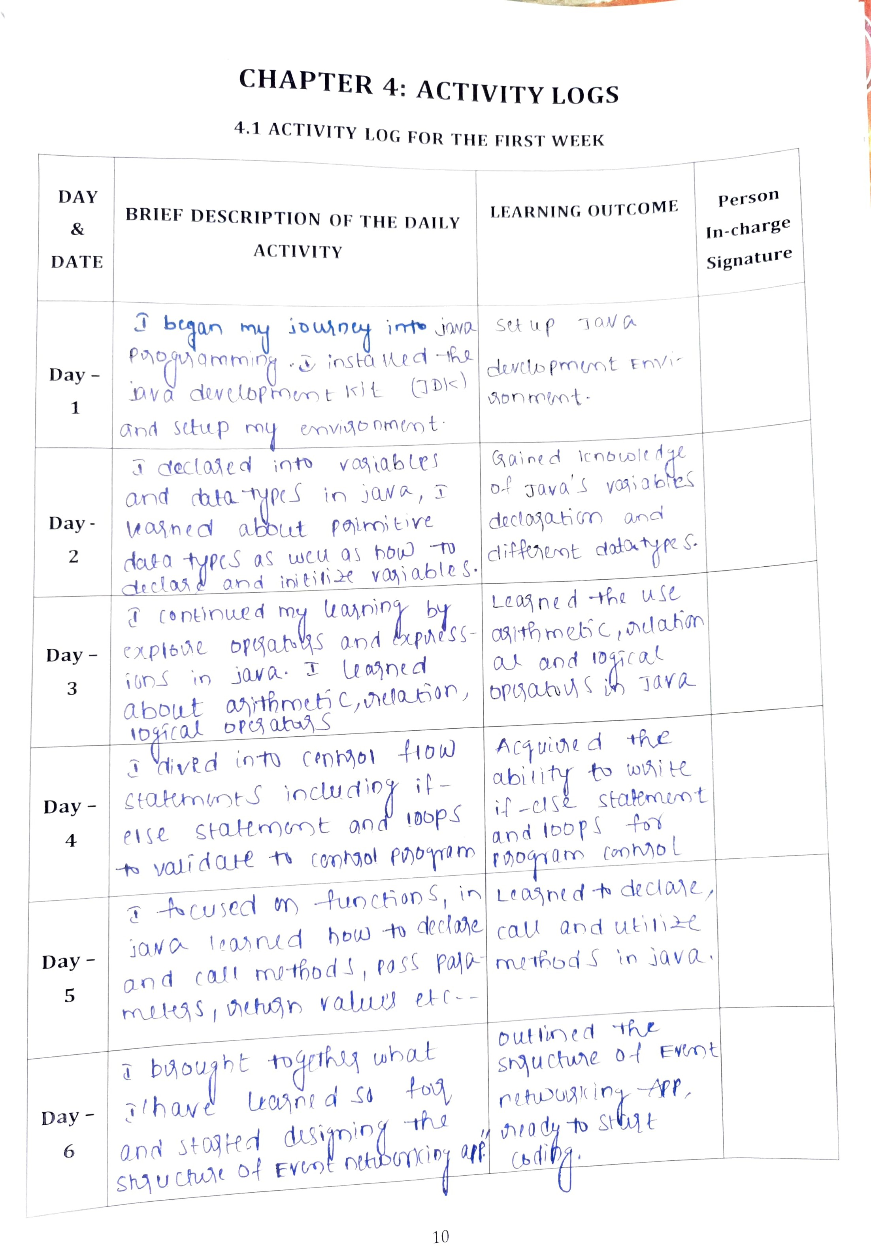

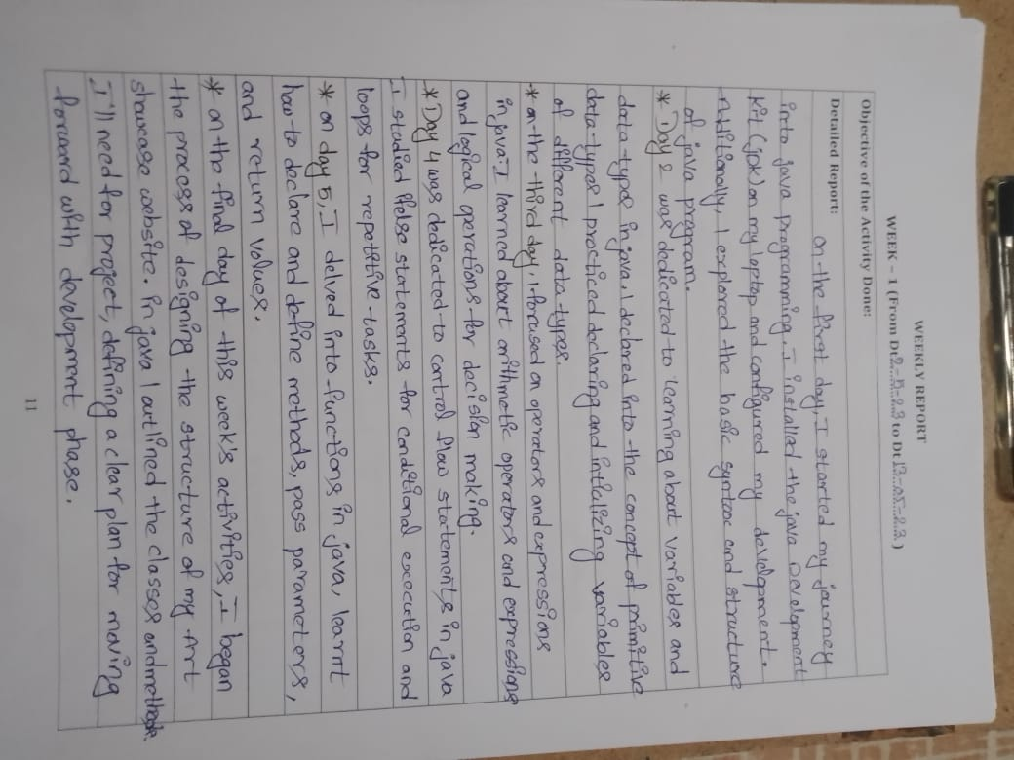

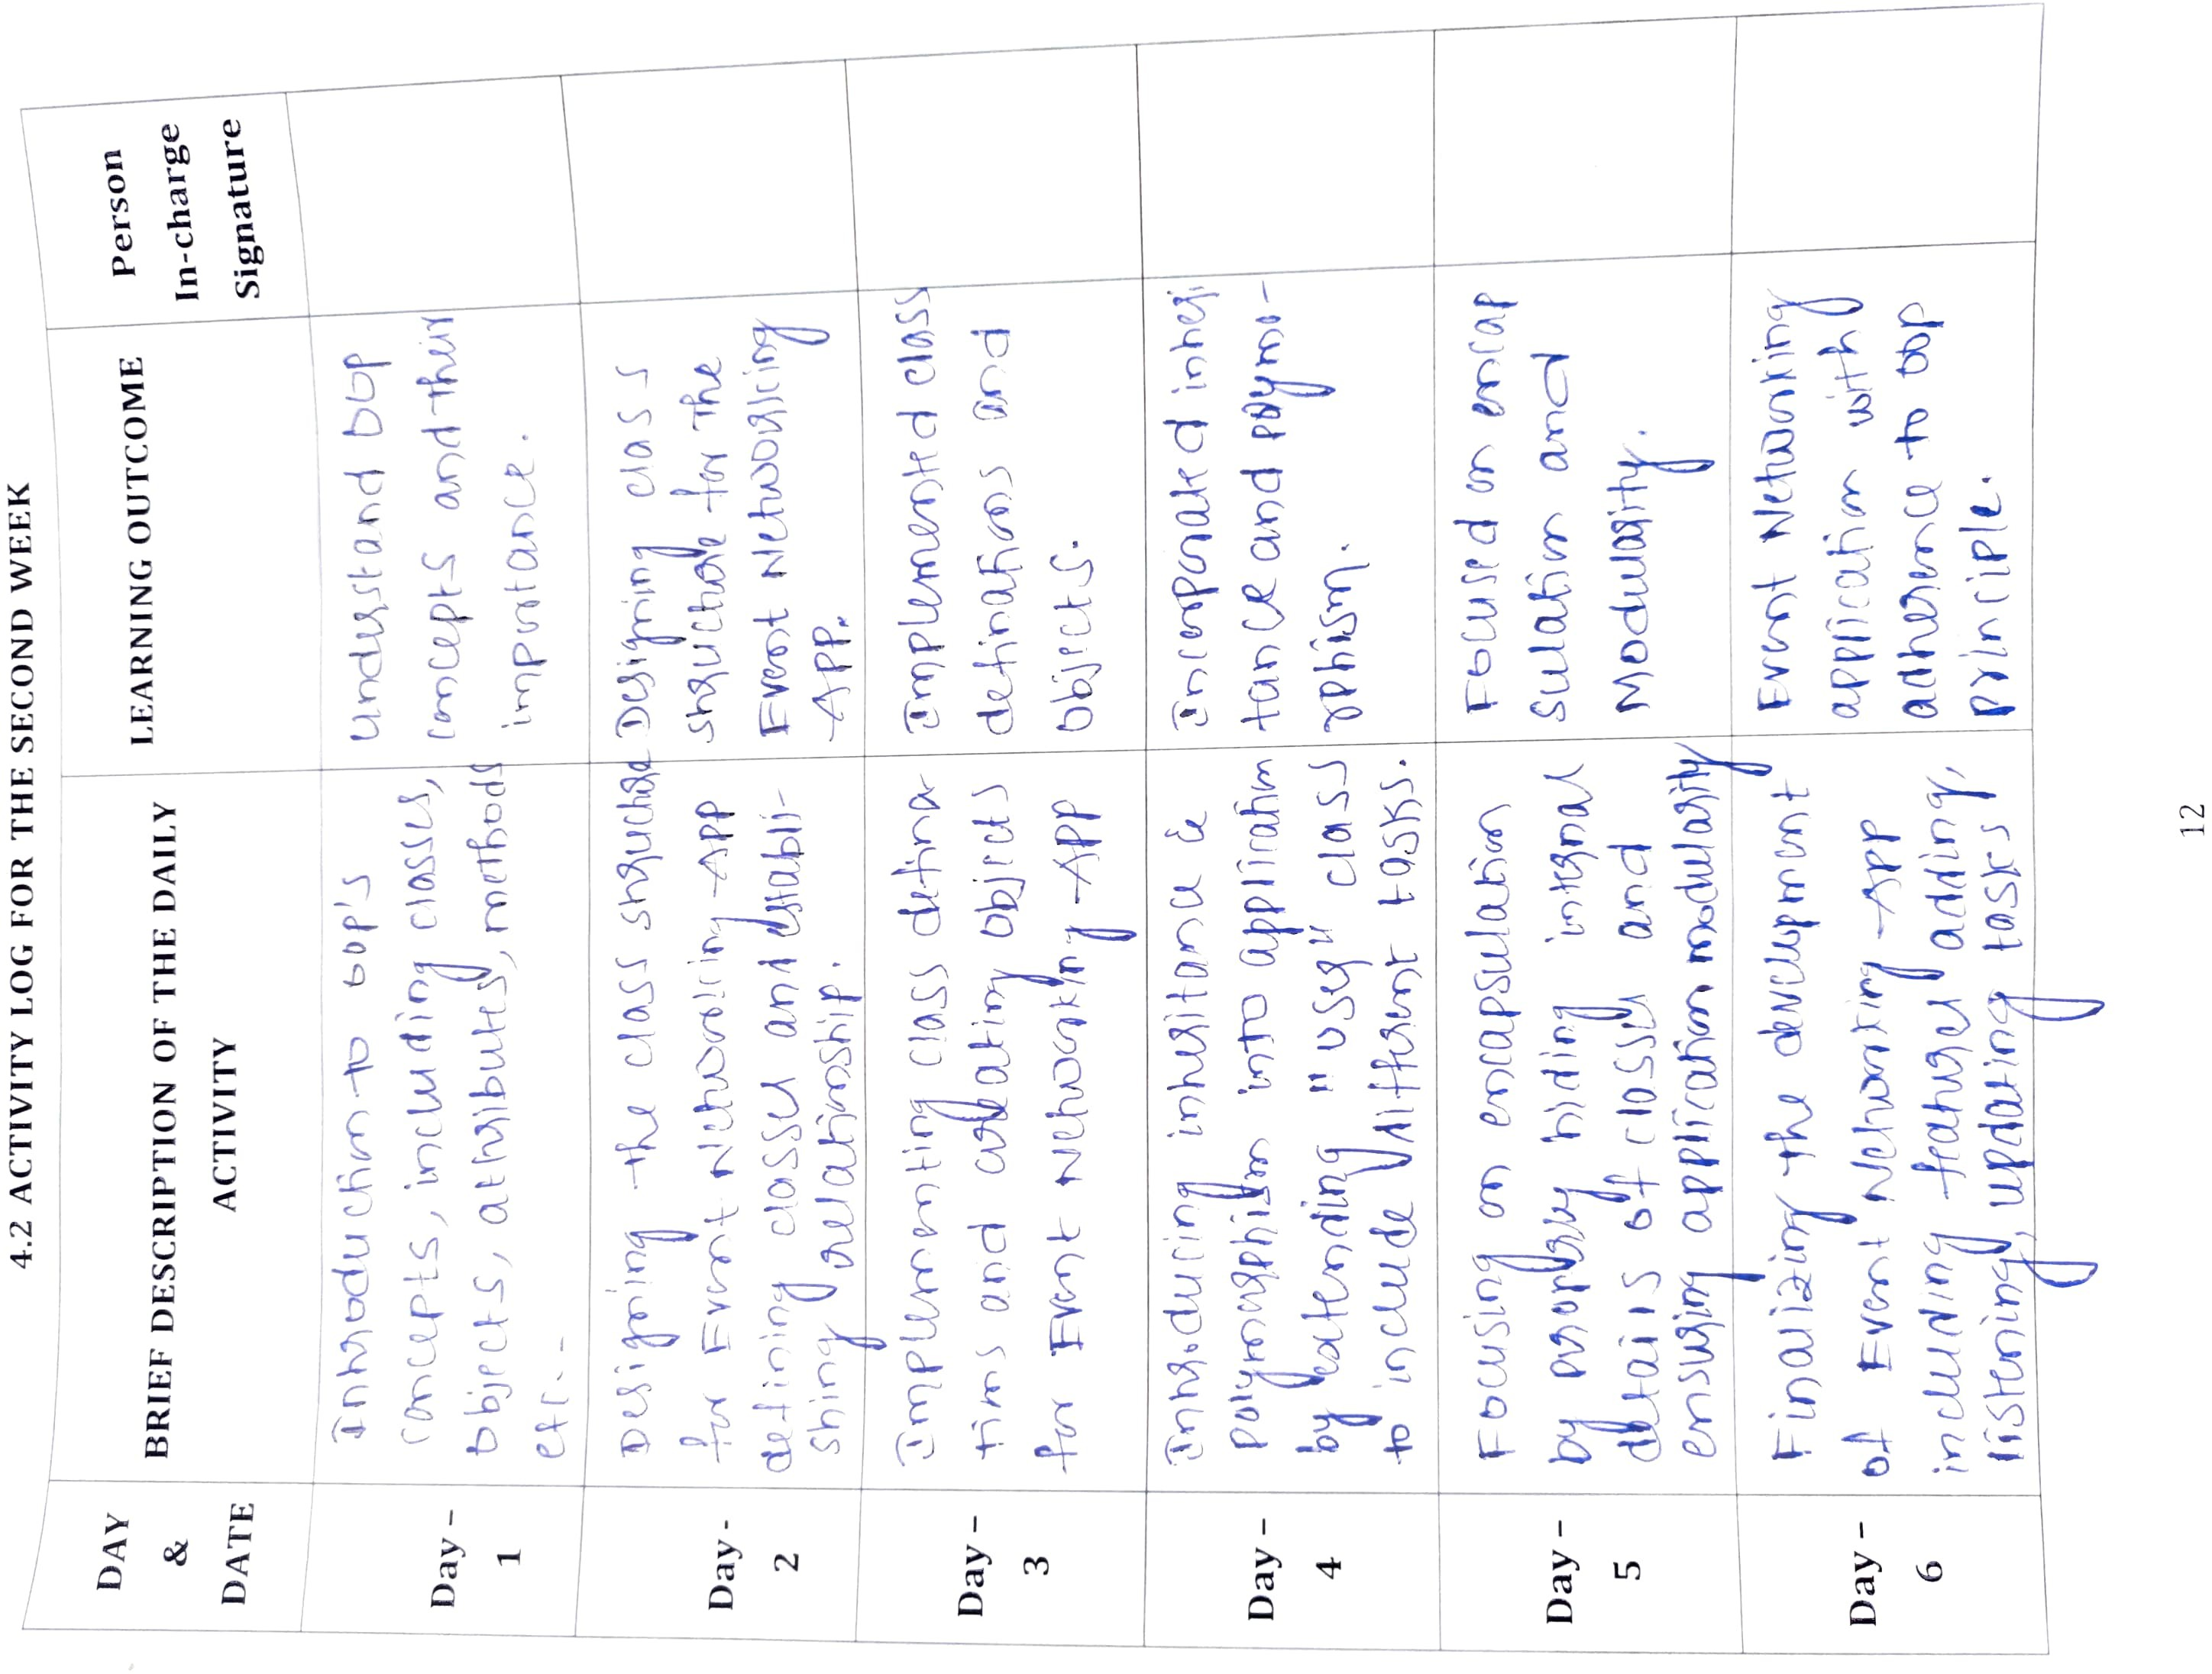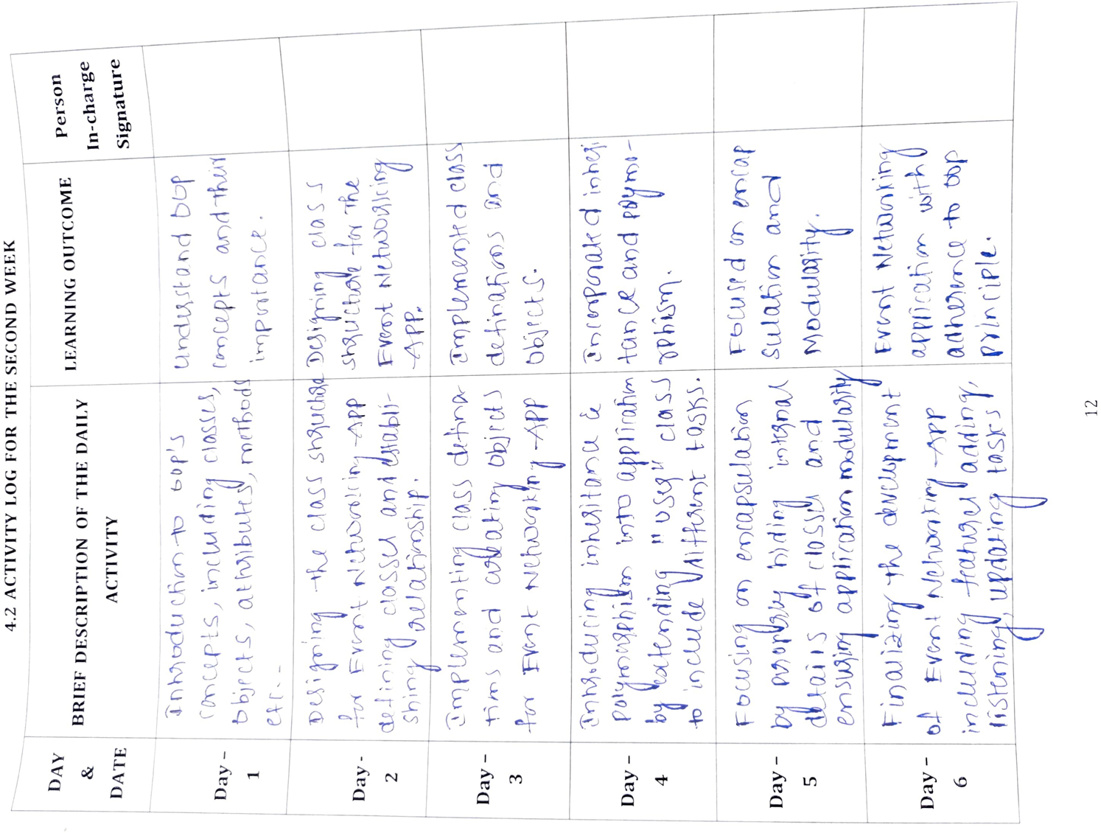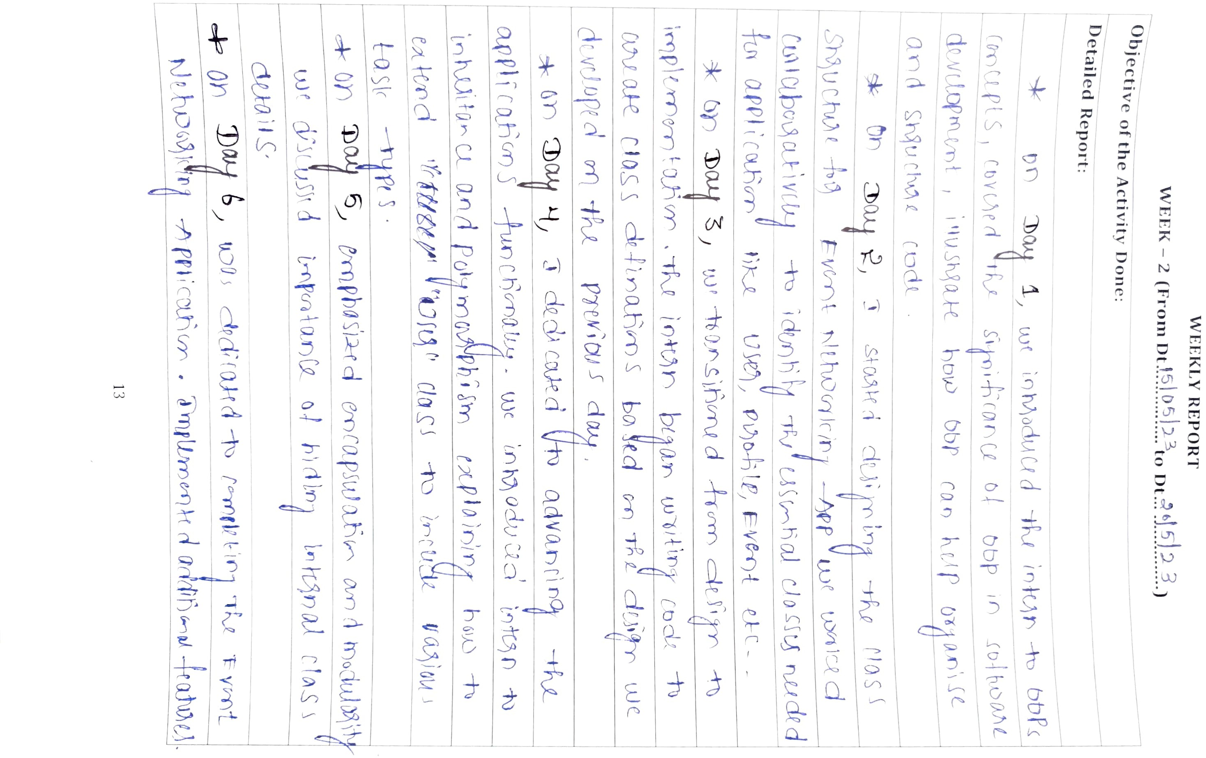

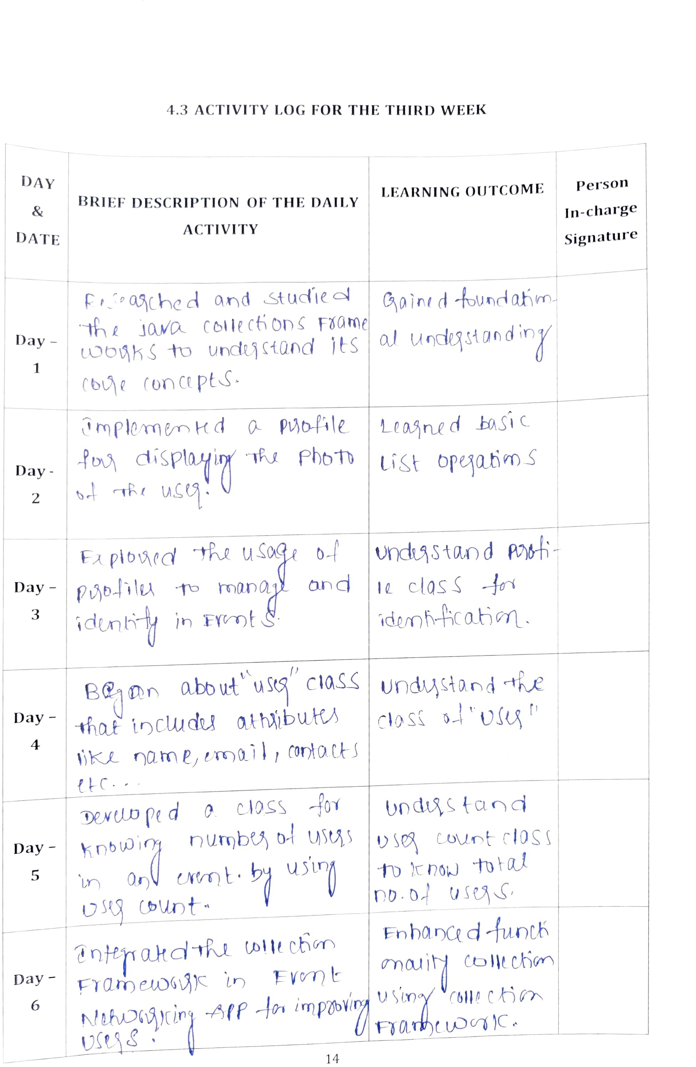

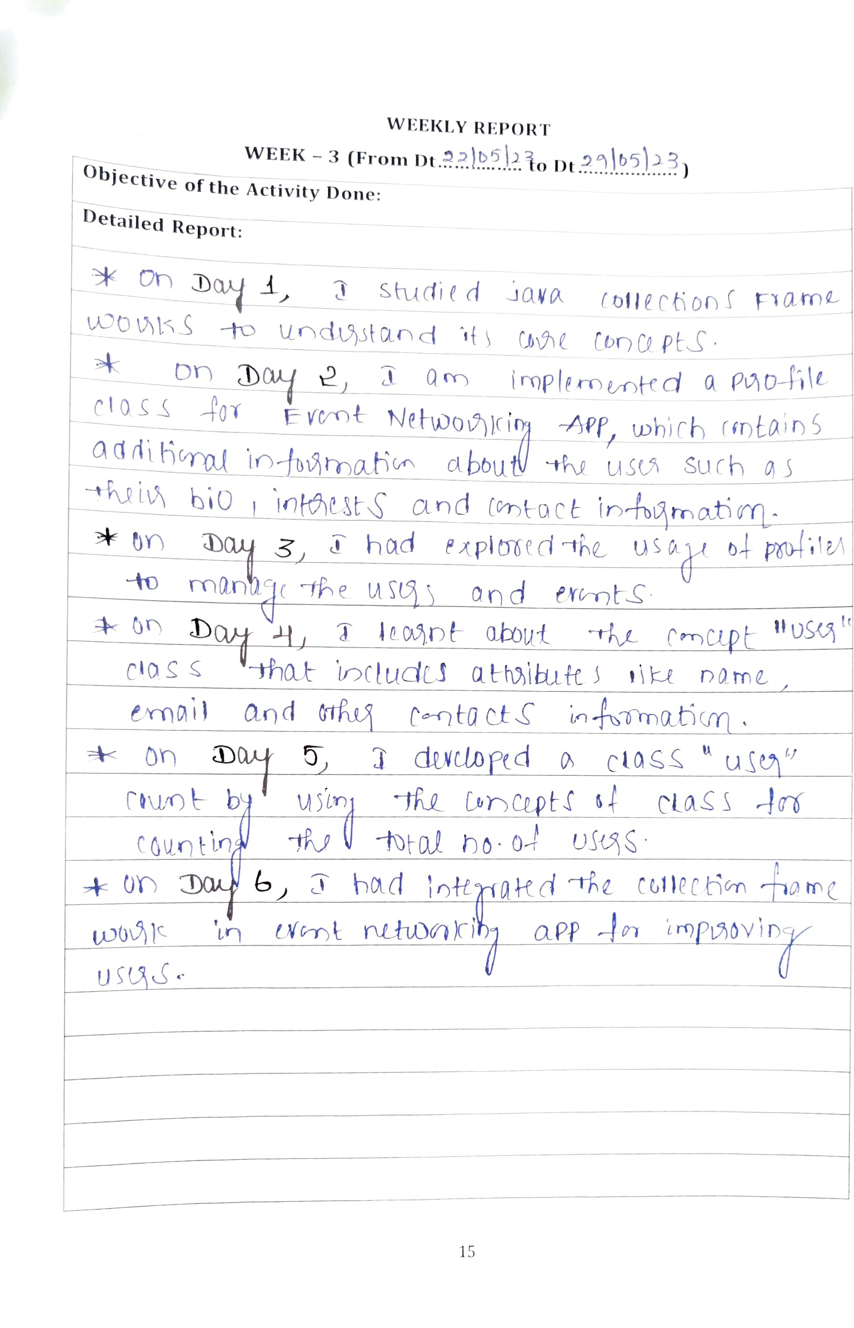

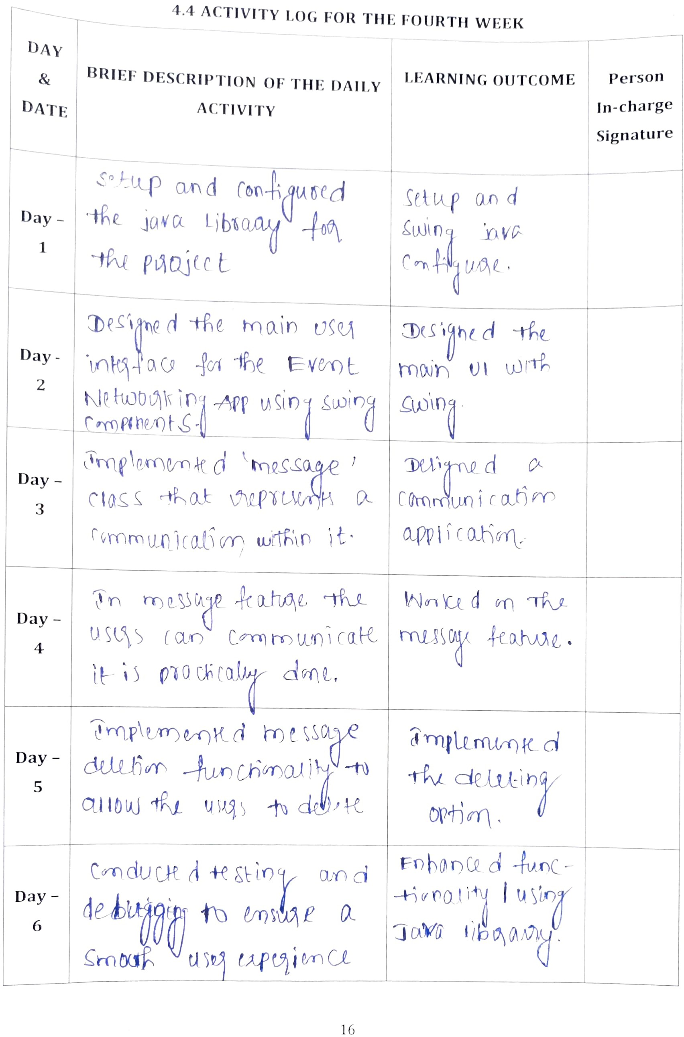

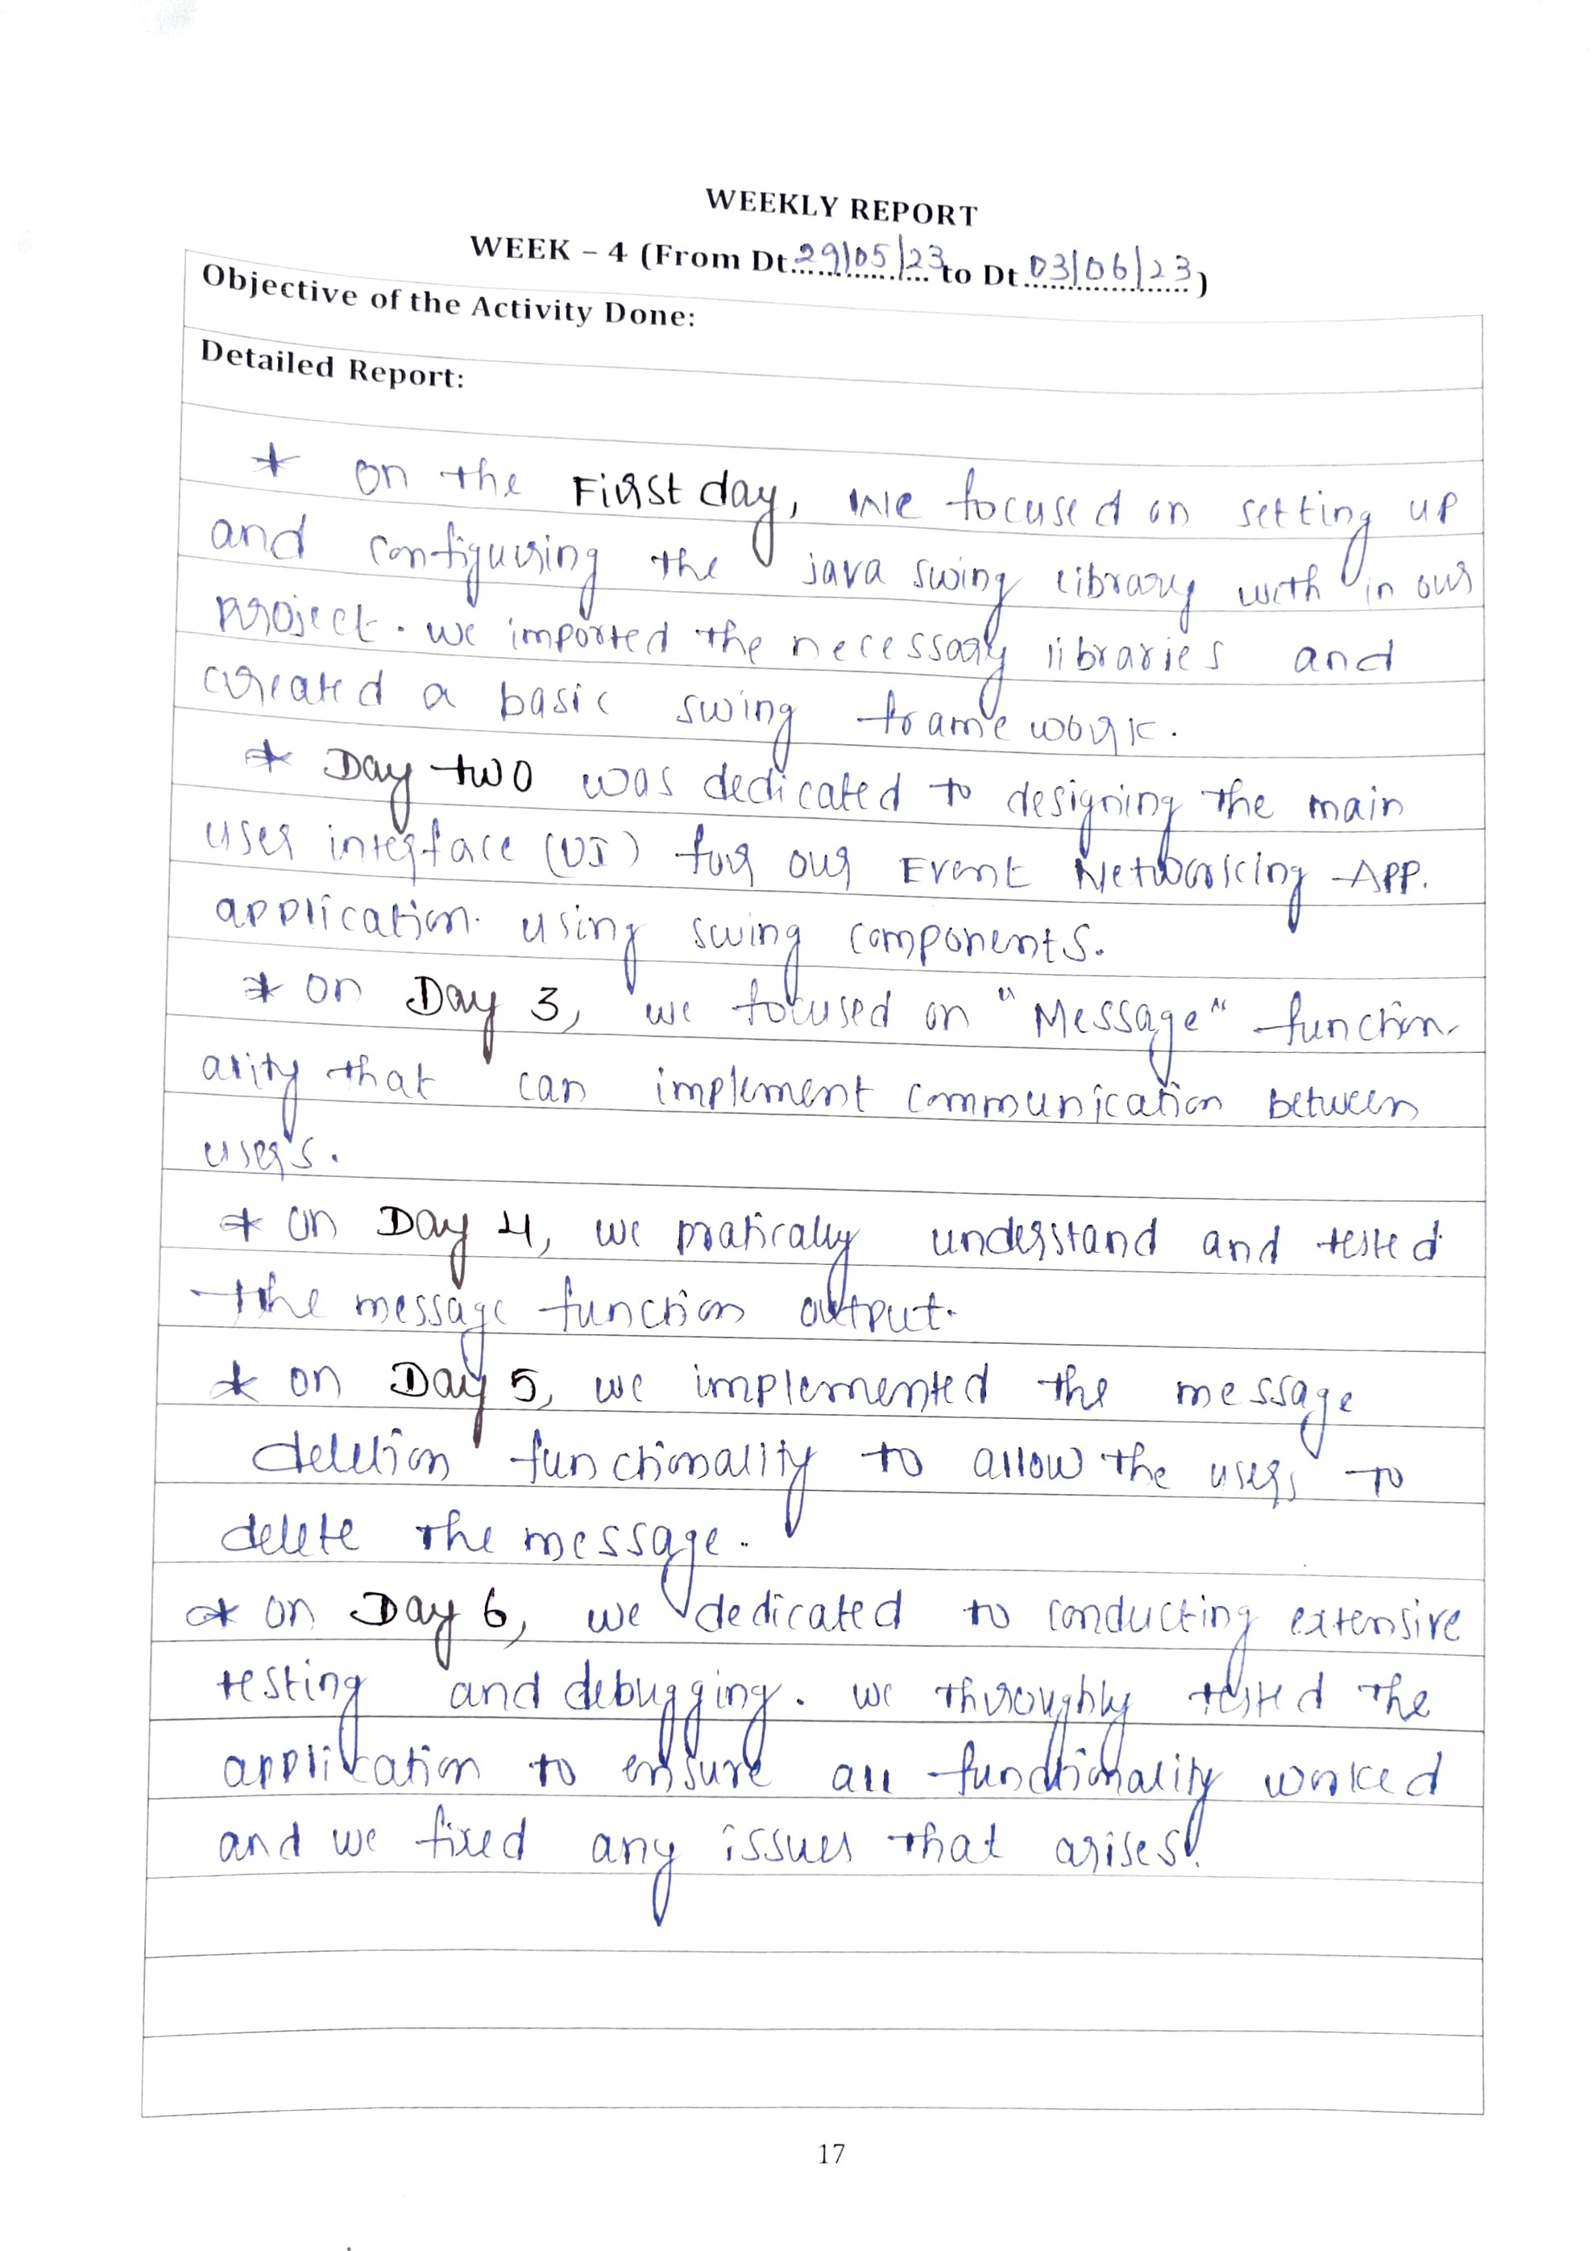

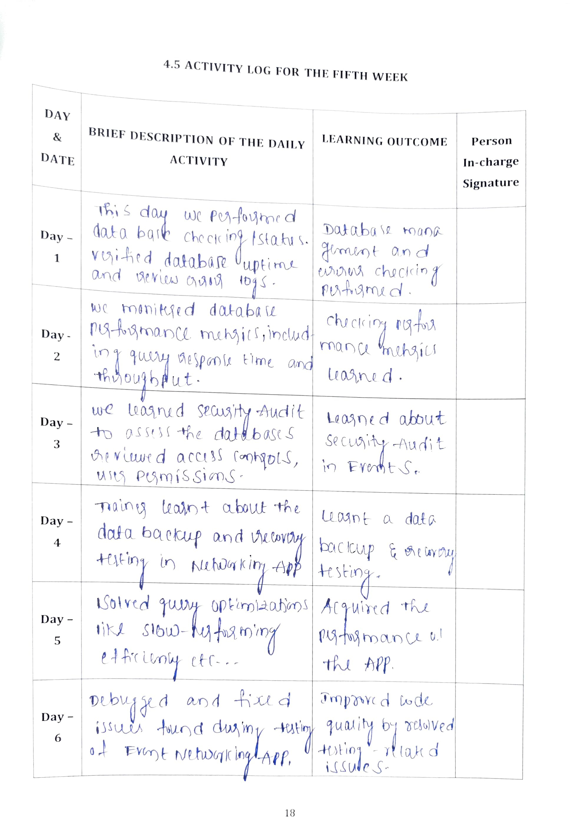

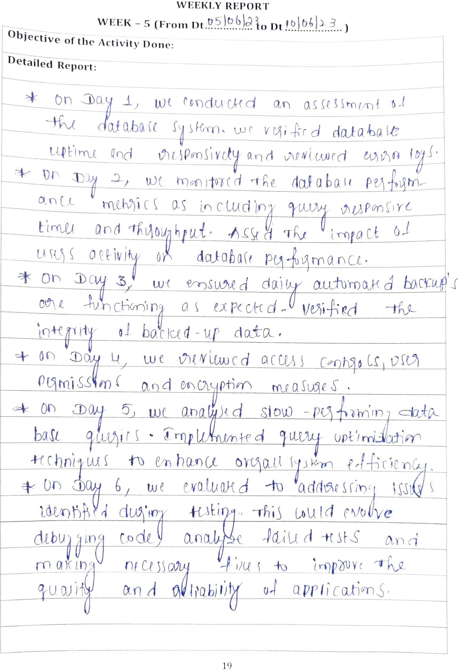

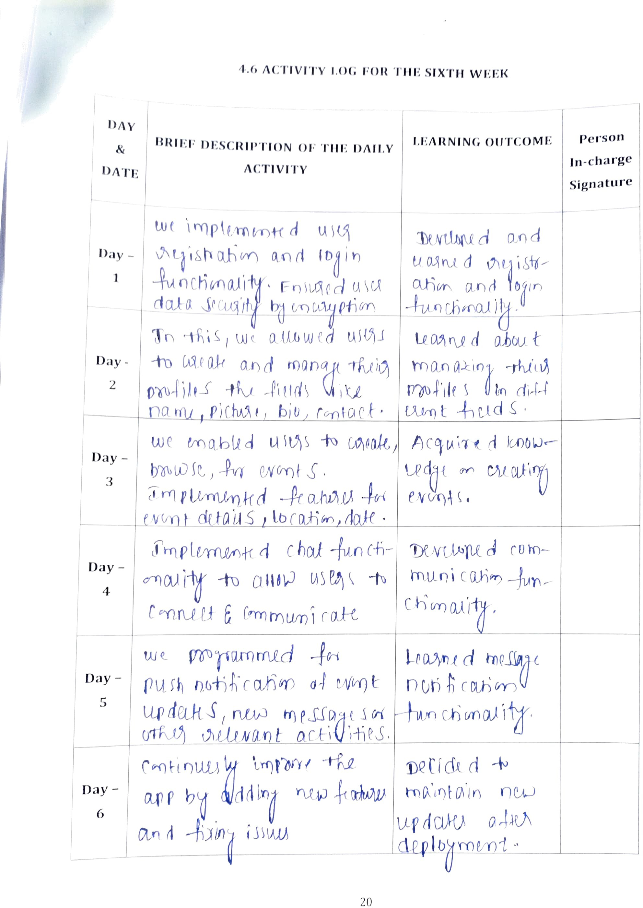

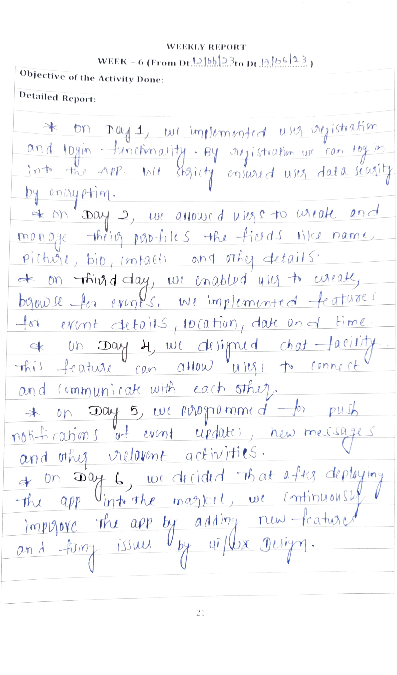

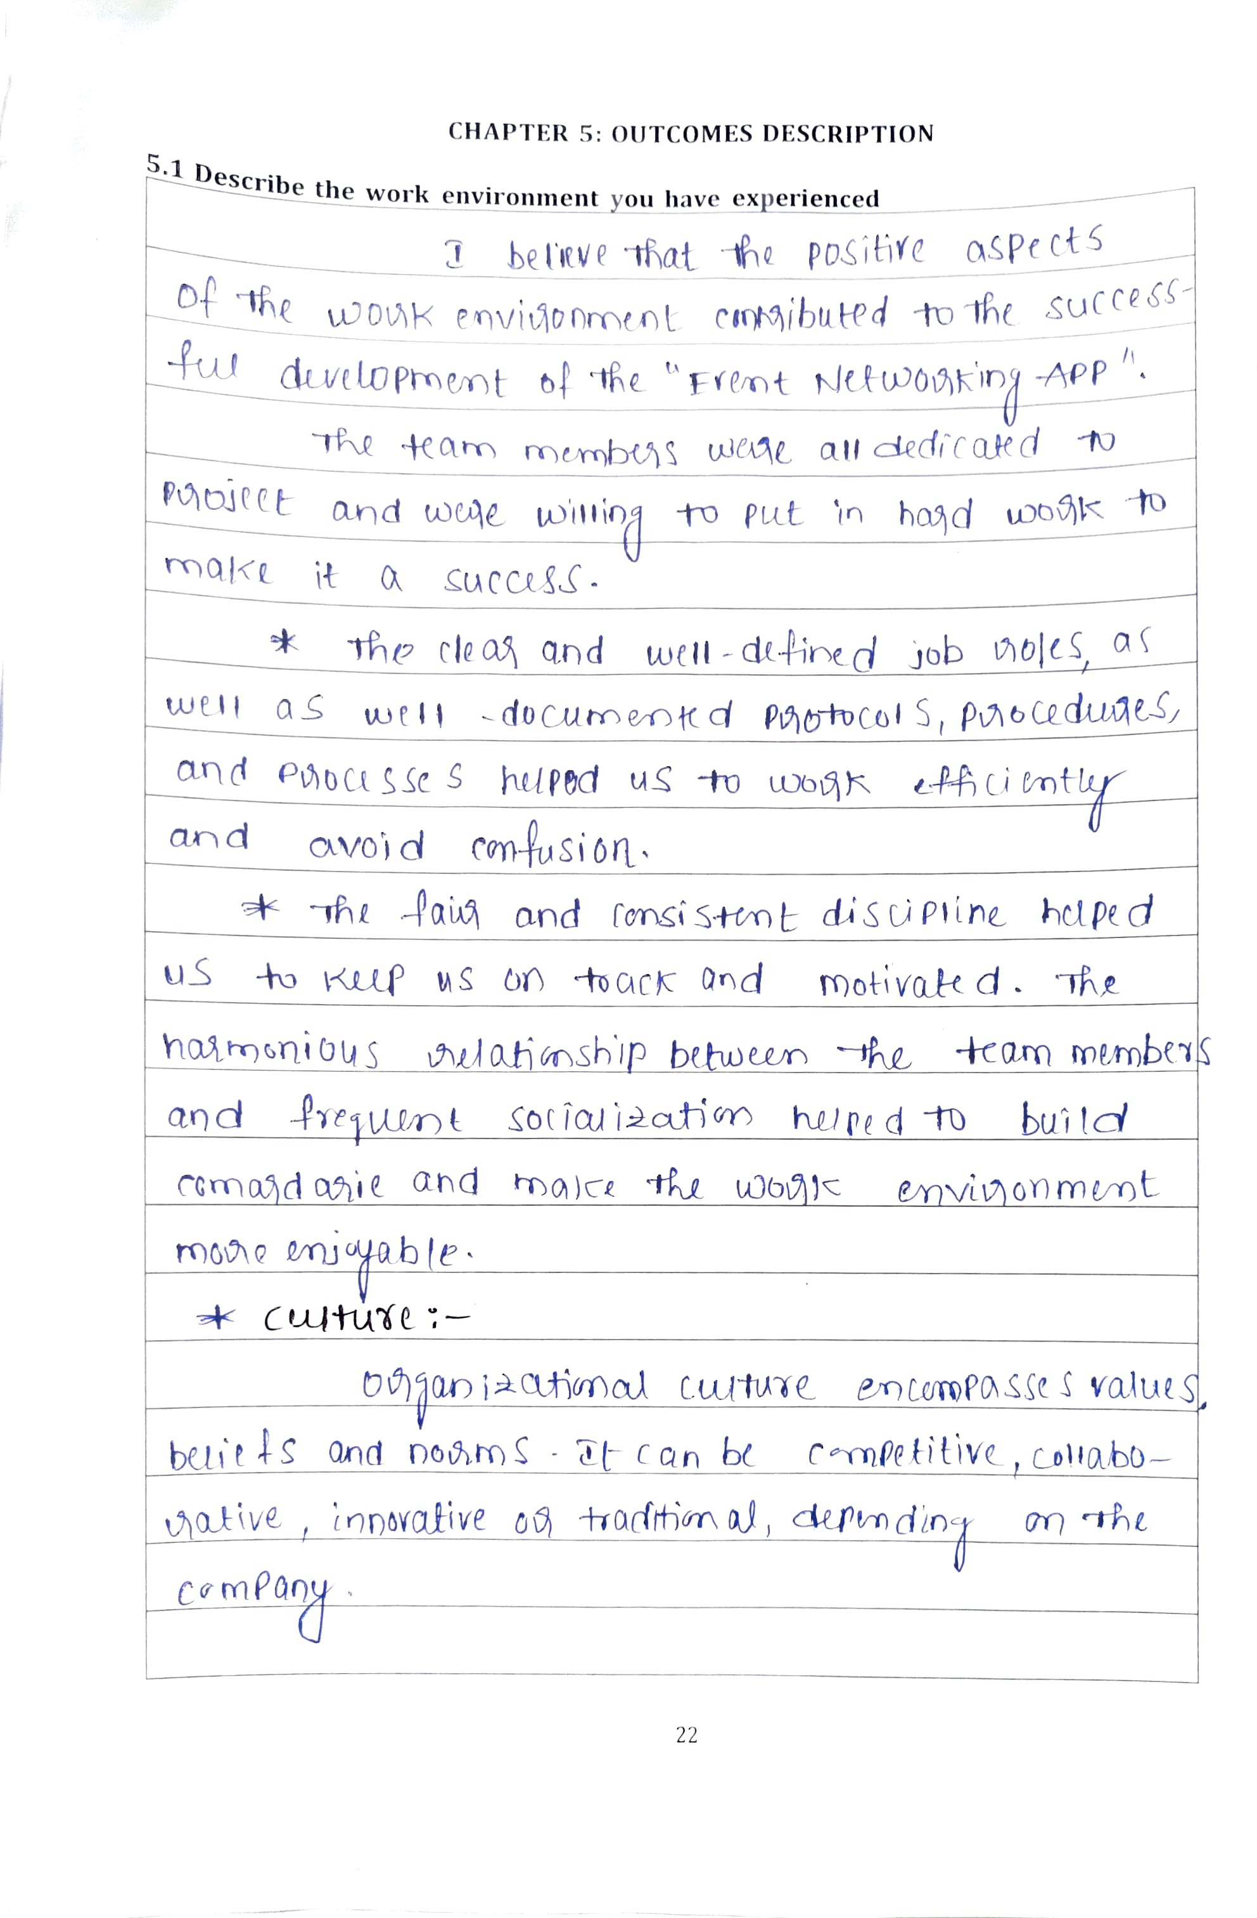

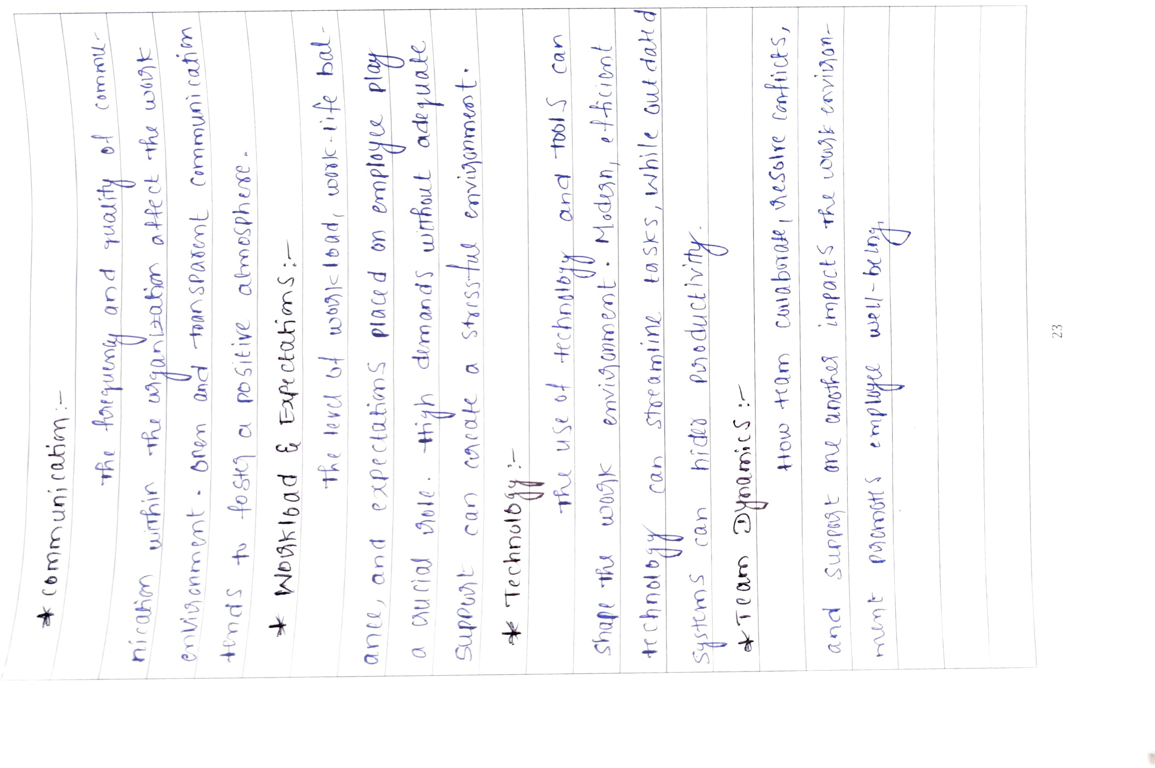

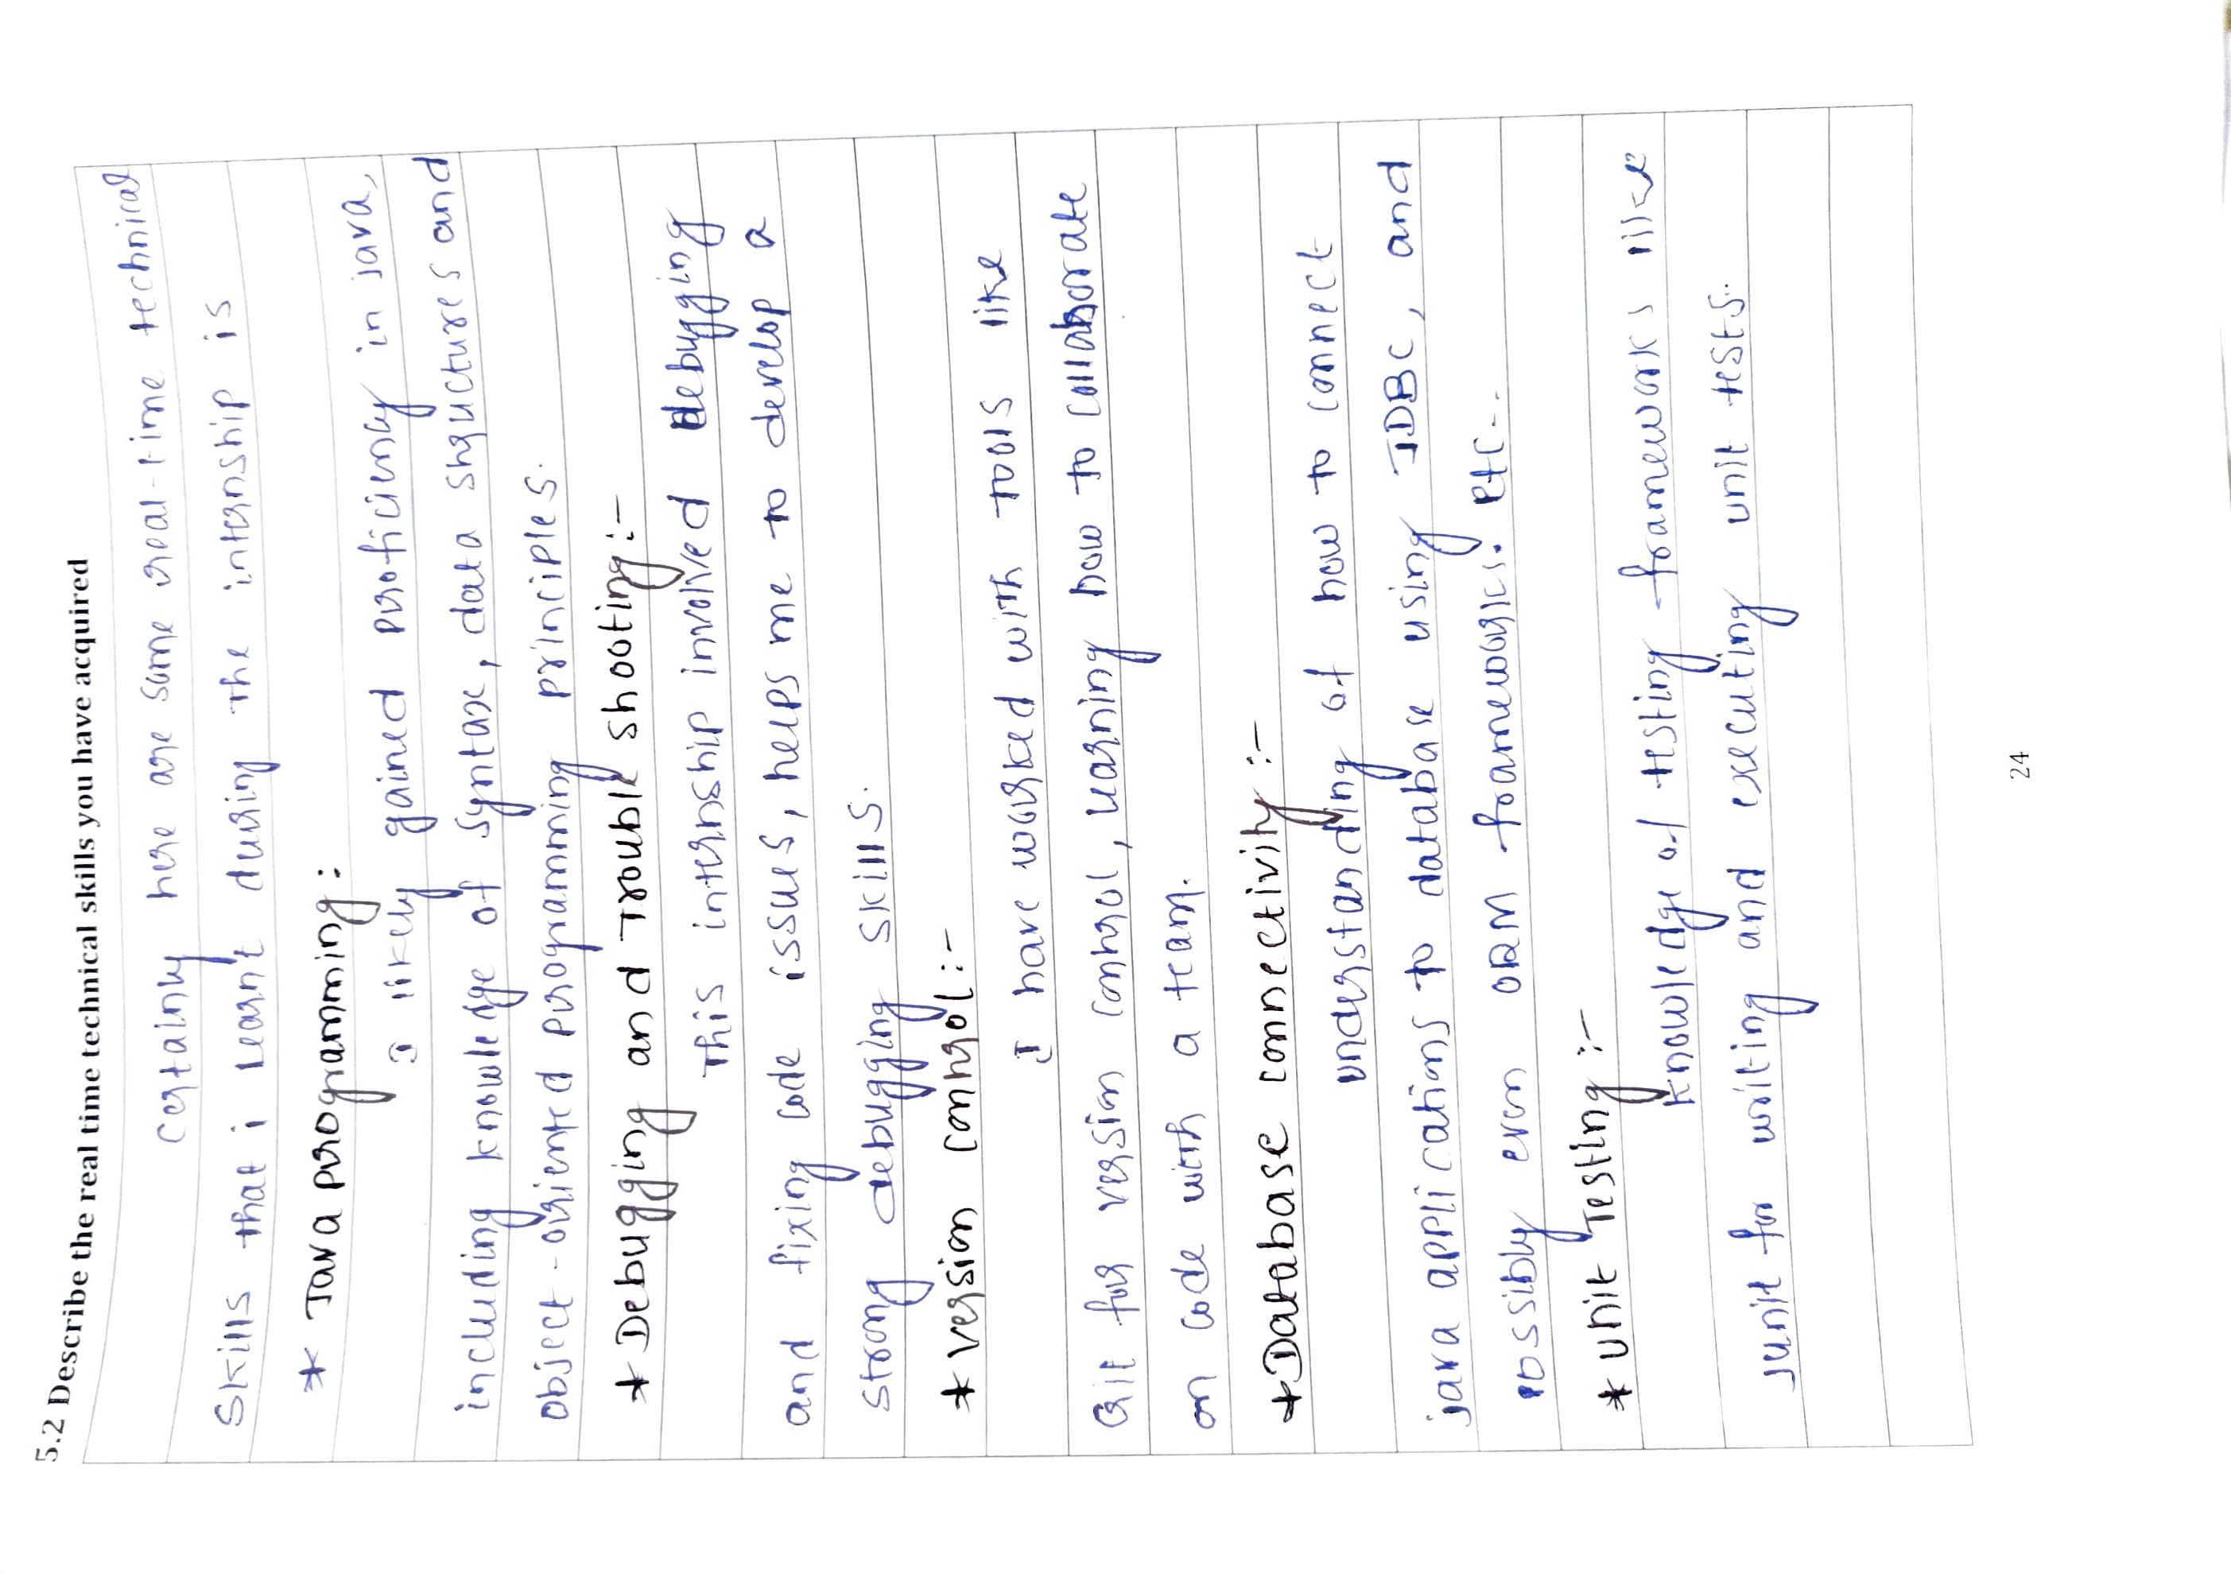

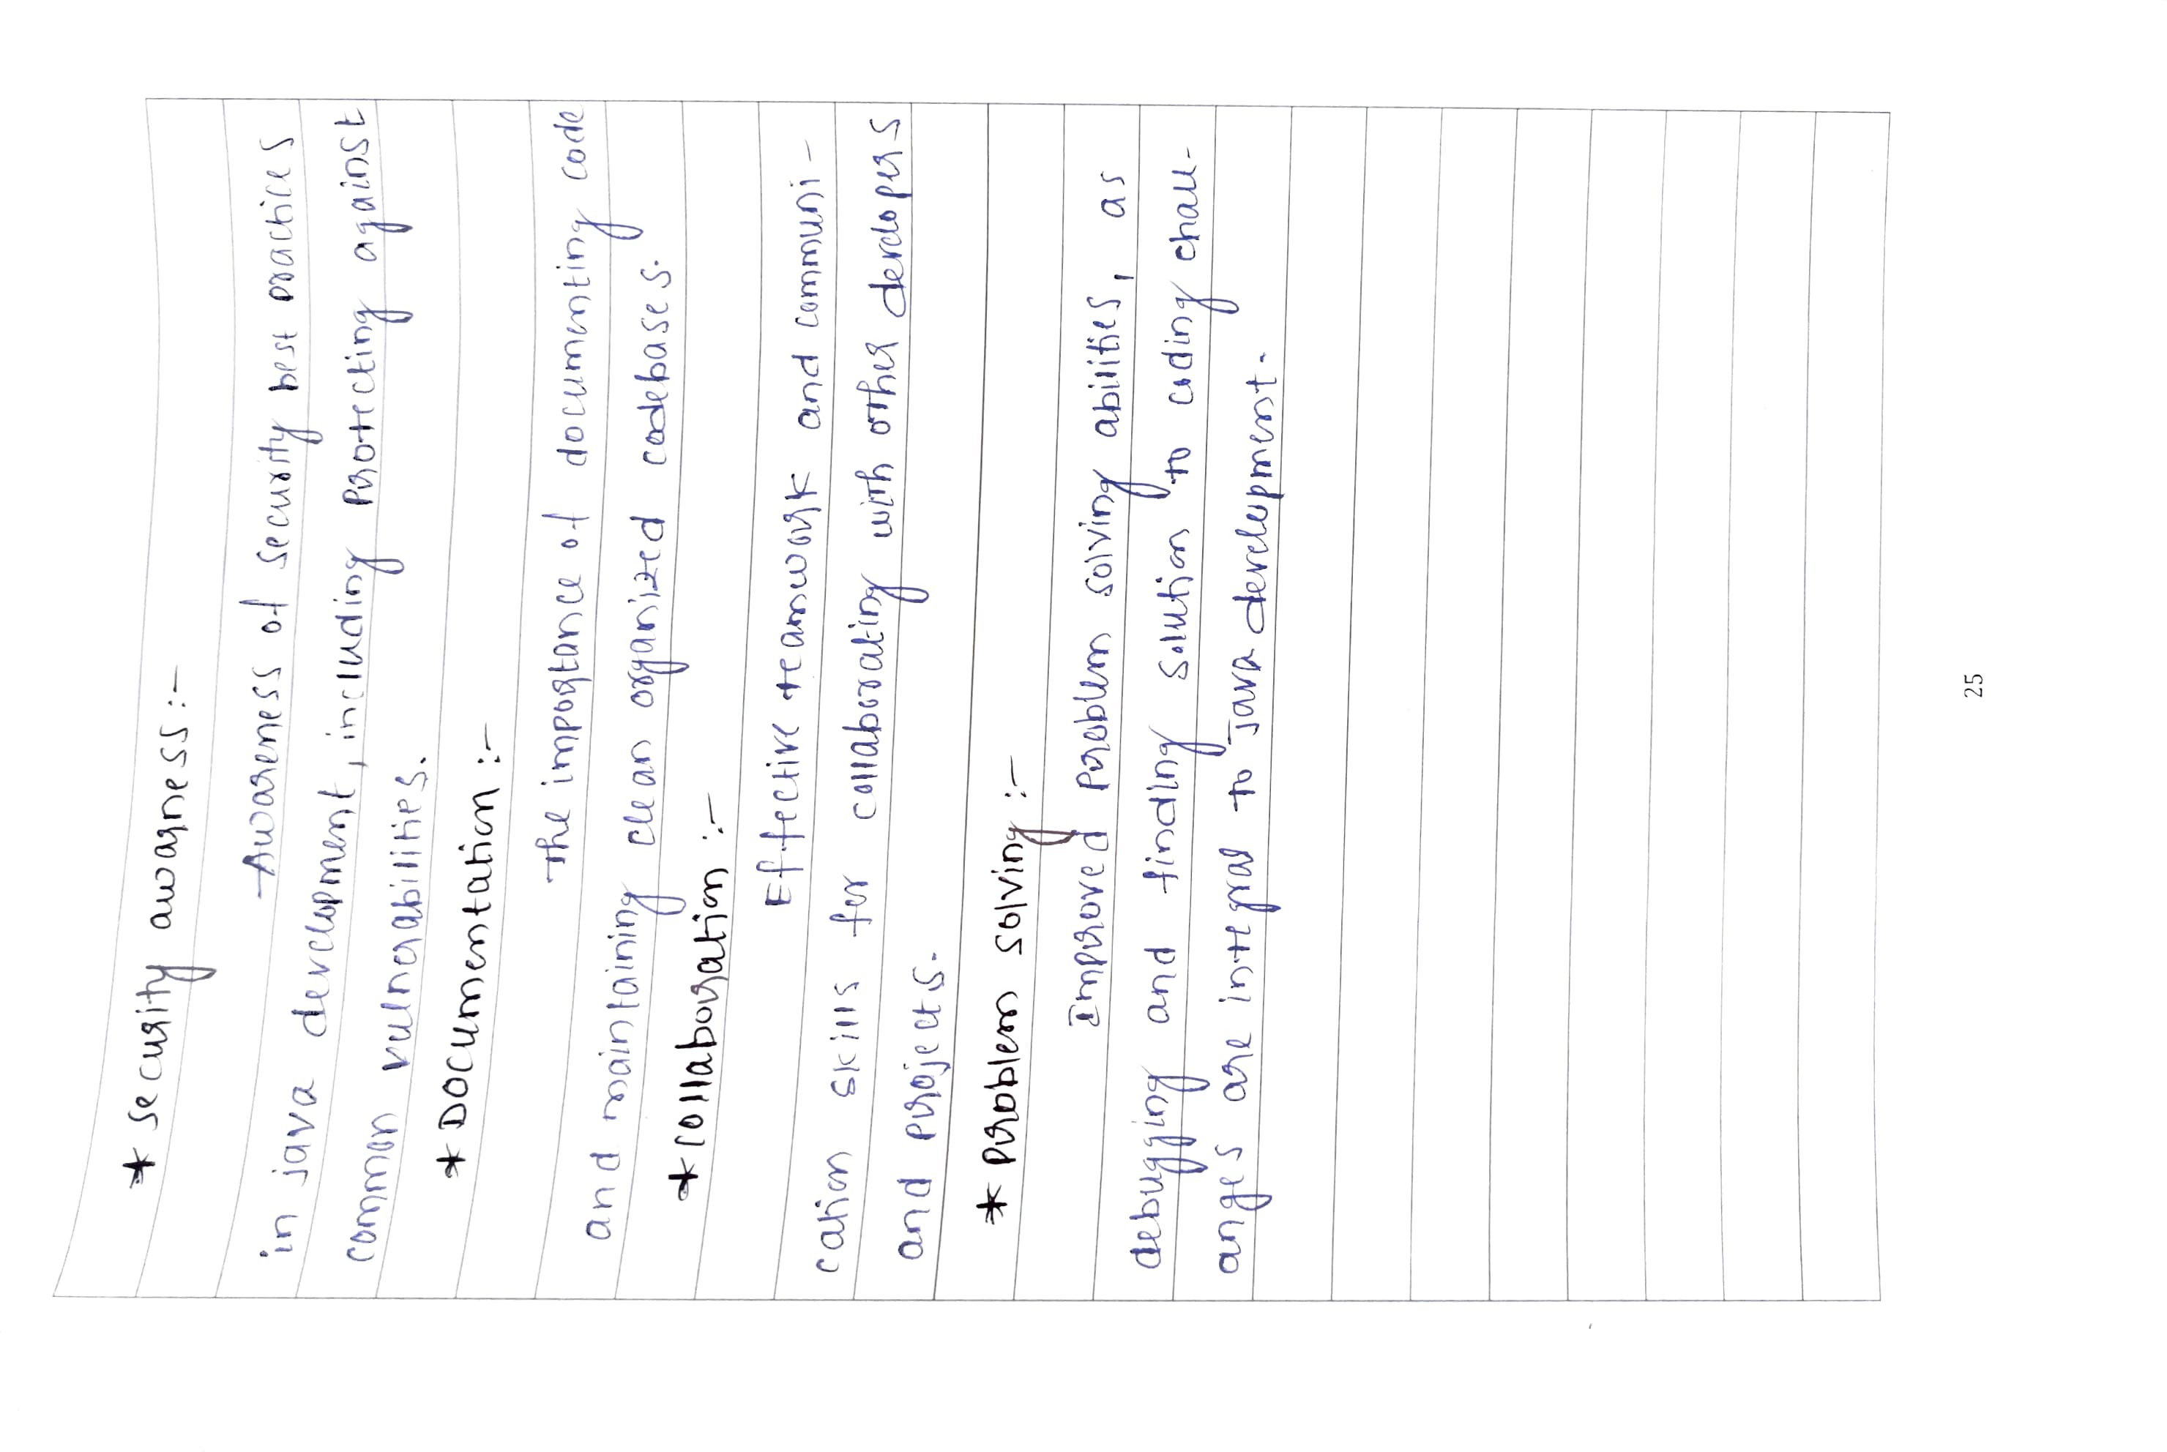

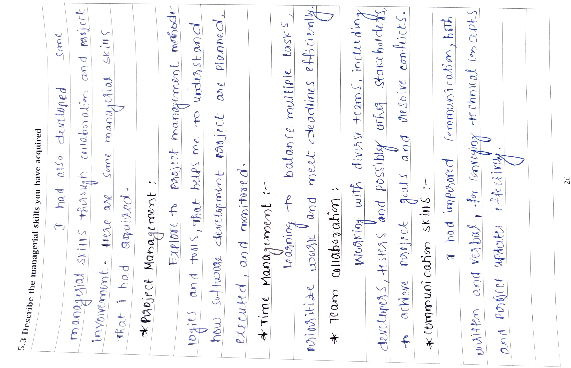

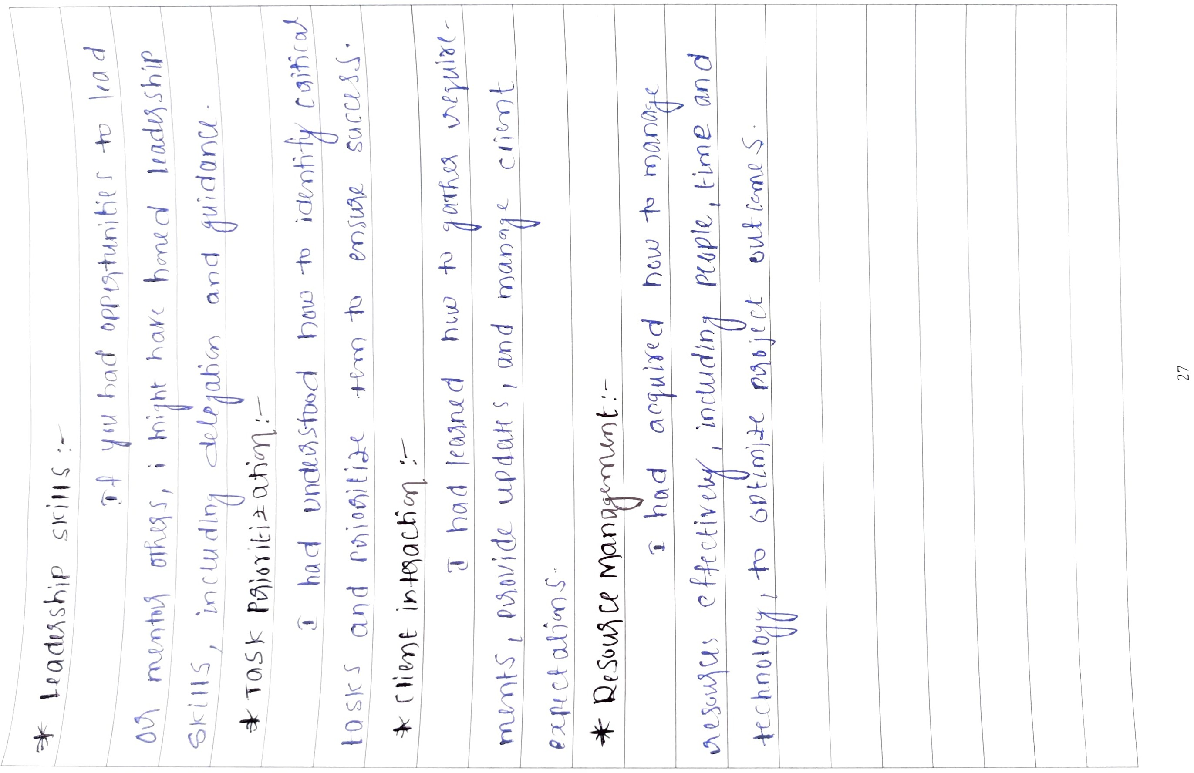

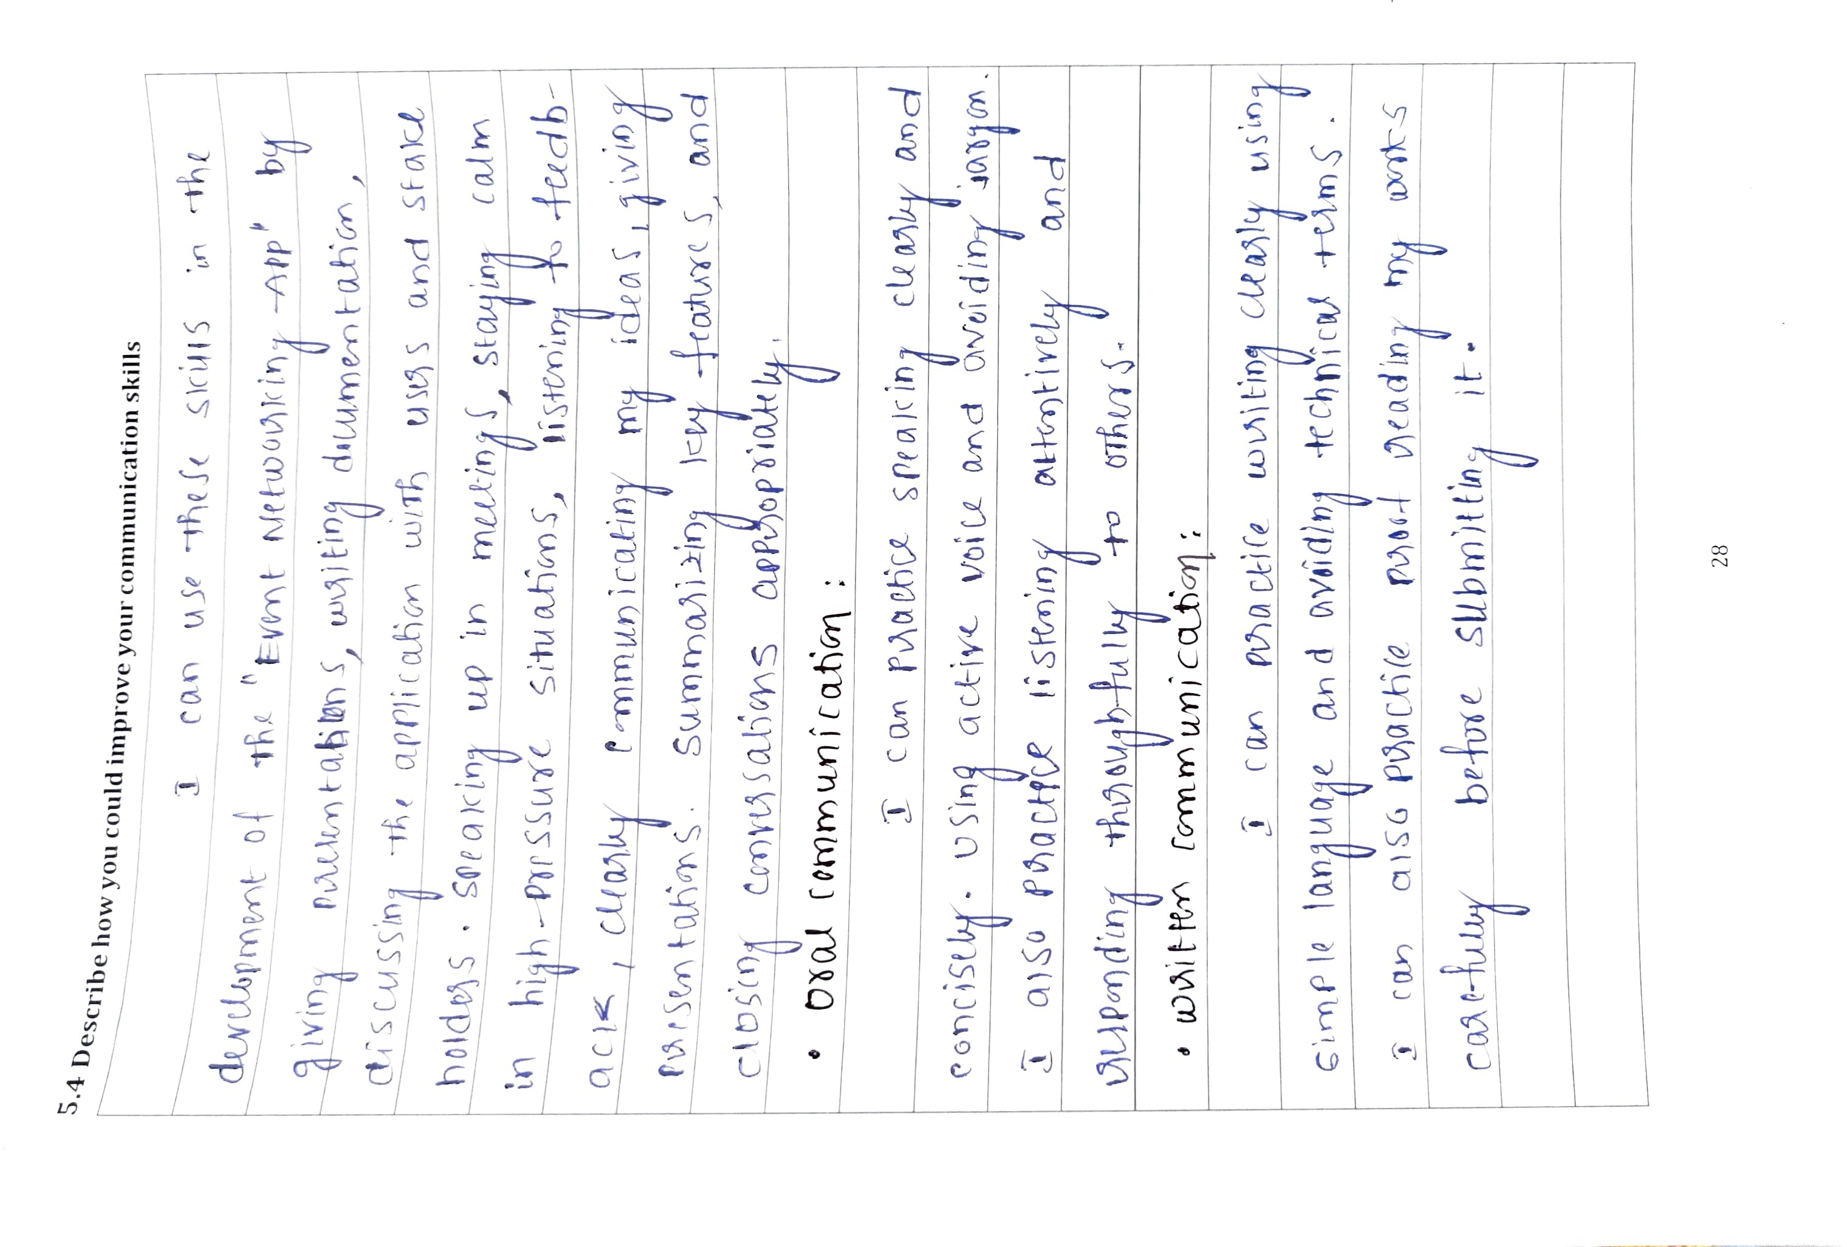

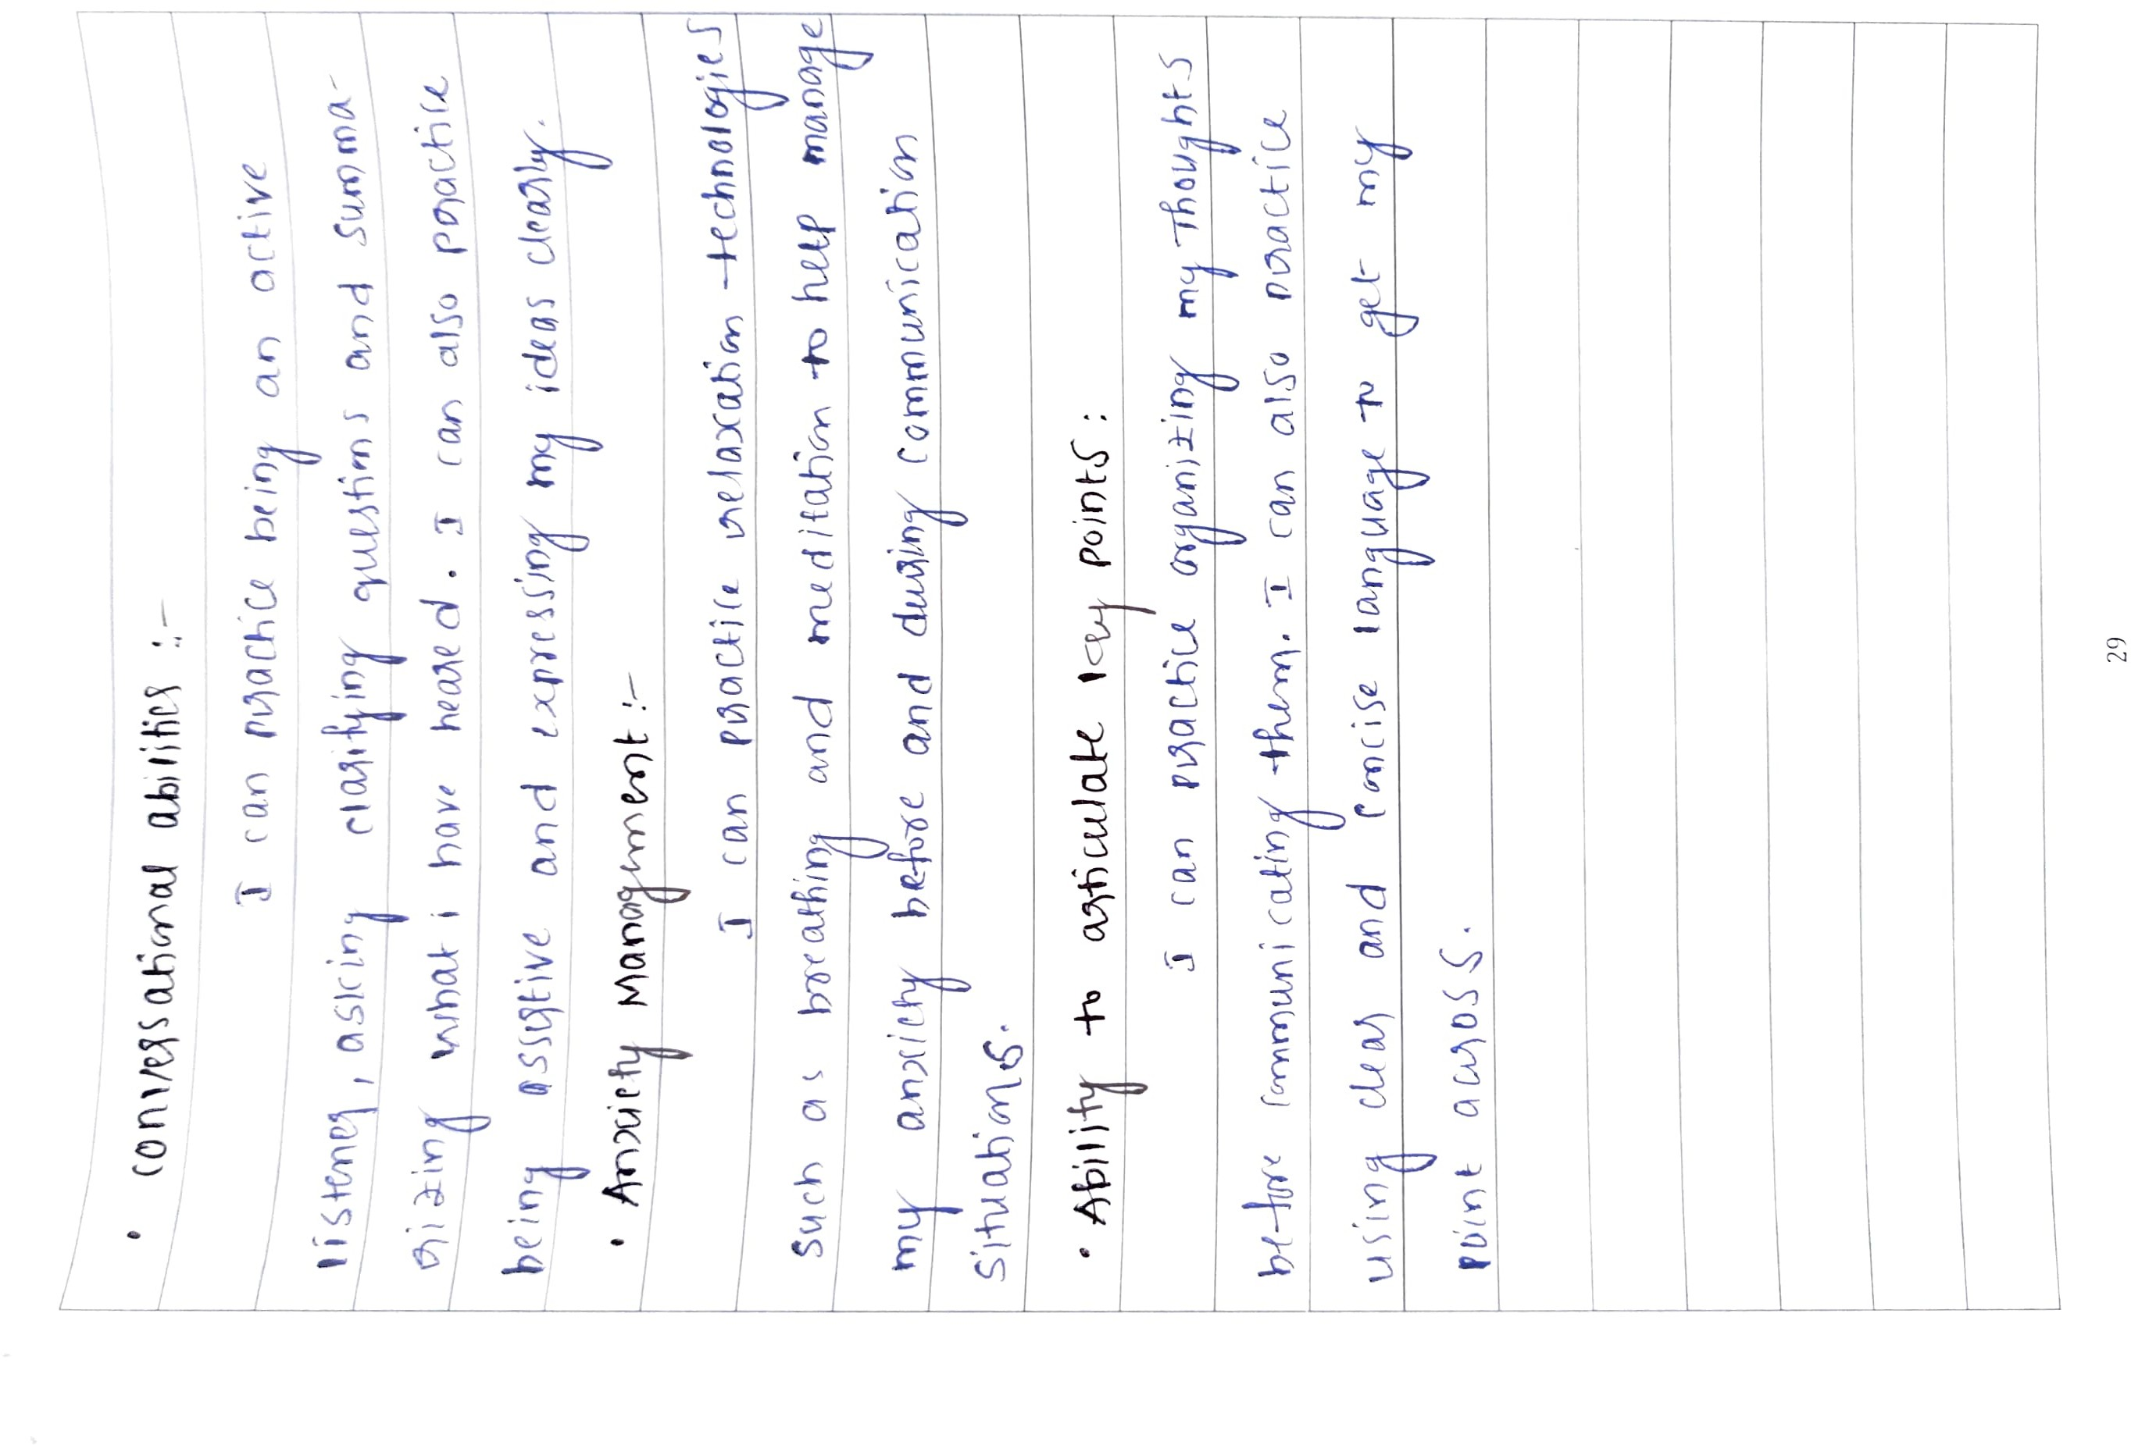

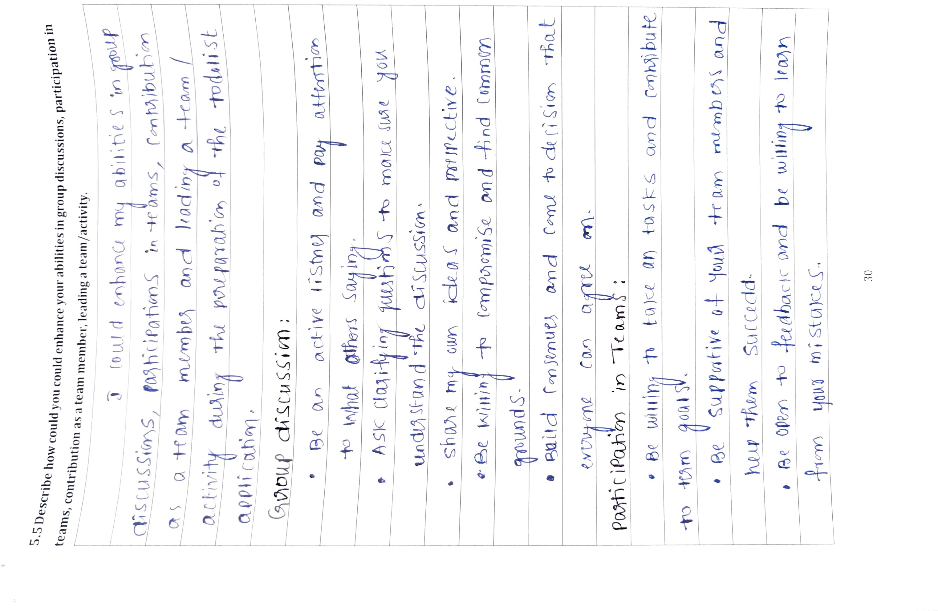

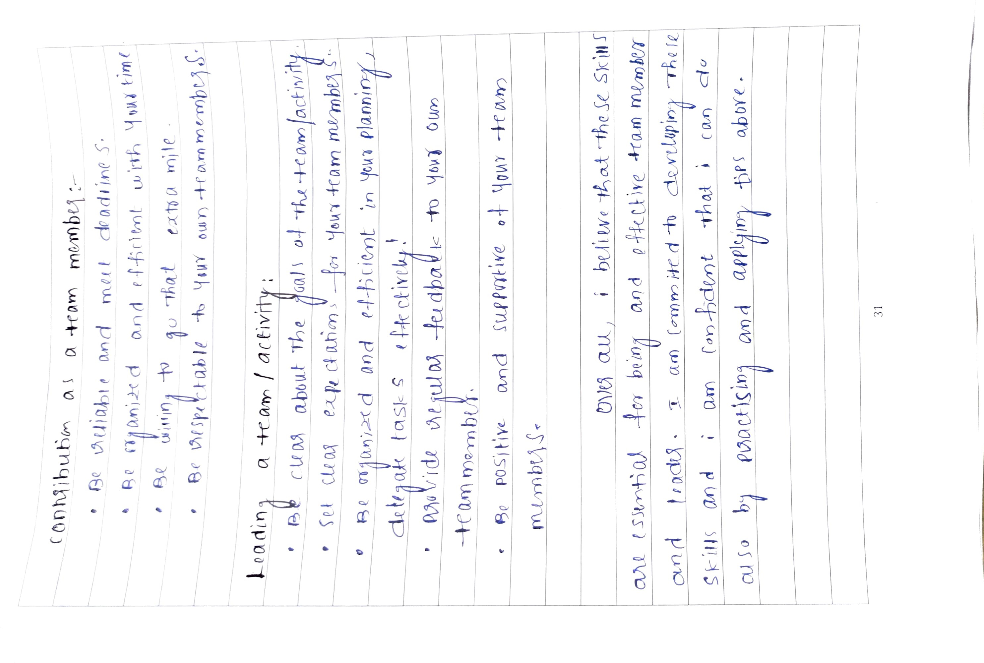

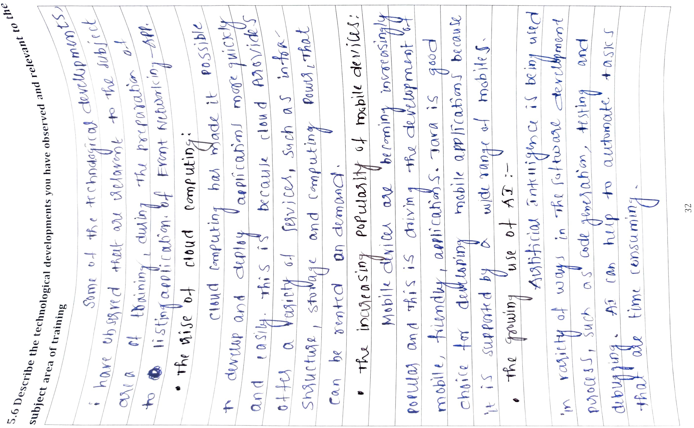

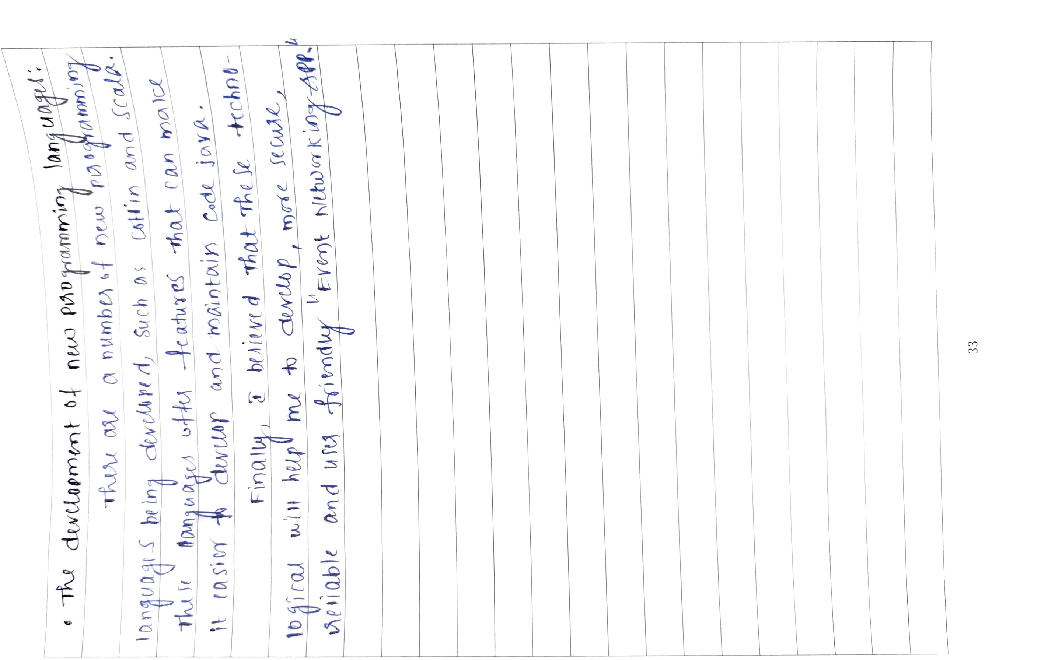

### CHAPTER 6 : CONCLUSION

The objective of this internship was to learn the basics of Java programming and to develop simple Art Showcase Website . The following objectives were achieved:

* Learned the basics of Java programming, including variables, data types, operators, control flow statements, functions, and classes.
* Learned how to use object-oriented programming (OOP) in Java, including classes, objects, inheritance, polymorphism, and encapsulation.
* Learned how to use the Java Collections Framework, which provides a set of classes forstoring and manipulating collections of data.
* Learned how to use the Java Swing library, which provides a set of graphical user interface (GUI) components.
* Learned how to test your code using unit testing frameworks.

The development and implementation of the Event Networking App have been a significant journey filled with challenges, learnings, and achievements. Throughout this project, we have successfully designed and launched an innovative platform that addresses the needs of event attendees and organizers.

I had worked tirelessly to create a user-friendly interface that facilitates seamless networking, information sharing, and engagement during events. We incorporated valuable features such as real-time chat, personalized event recommendations, and interactive event schedules, which have garnered positive feedback from users.

This project has not only enhanced my technical skills but has also taught me the importance of effective communication, collaboration, and adaptability in a fast-paced development environment. Working closely with colleagues from different backgrounds has broadened my perspective and improved my teamwork abilities.

I want to express my gratitude to the entire team for their dedication and support throughout this journey. This experience has been invaluable in shaping my understanding of software development, project management, and the dynamic nature of the tech industry.

# STUDENT SELF –

**EVALUATION**

**Student *Self Evaluation of the Short-Term Internship***

Student Name: & Registration No:

To

Date of Evaluation:

Name & Address of the Supervisor

with Mobile Number:

**Please rate your performance in the following areas:**

**Rating Scale: Letter grade of CGPA calculation to be provided**

|  |  |  |  |  |  |
| --- | --- | --- | --- | --- | --- |
| **1) Oral communication** | **1** | **2** | **3** | **4** | **5** |
| **2) Written communication** | **1** | **2** | **3** | **4** | **5** |
| **3) Initiative** | **1** | **2** | **3** | **4** | **5** |
| **4) Interaction with staff** | **1** | **2** | **3** | **4** | **5** |
| **5) Attitude** | **1** | **2** | **3** | **4** | **5** |
| **6) Dependability** | **1** | **2** | **3** | **4** | **5** |
| **7) Ability to learn** | **1** | **2** | **3** | **4** | **5** |
| **8) Planning and organization** | **1** | **2** | **3** | **4** | **5** |
| **9) Professionalism** | **1** | **2** | **3** | **4** | **5** |
| **10) Creativity** | **1** | **2** | **3** | **4** | **5** |
| **11) Quality of work** | **1** | **2** | **3** | **4** | **5** |
| **12) Productivity** | **1** | **2** | **3** | **4** | **5** |
| **13) Progress of learning** | **1** | **2** | **3** | **4** | **5** |
| **14) Adaptability to organization’s culture/policies** | **1** | **2** | **3** | **4** | **5** |
| **15) OVERALL PERFORMANCE** | **1** | **2** | **3** | **4** | **5** |

**Signature of the Student**

# EVALUATION BY THE SUPERVISOR

***Evaluation by the Supervisor of the Intern Organisation***

Student Name: & Registration No:

Term of Internship:

From

To

Date of Evaluation:

Name & Address of the Supervisor with Mobile Number:

**Please rate the student’s performance in the following areas:**

**Please note that your evaluation shall be done independent of the student’s self-evaluation Rating Scale: 1 is lowest and 5 is highest rank**

|  |  |  |  |  |  |
| --- | --- | --- | --- | --- | --- |
| **1) Oral communication** | **1** | **2** | **3** | **4** | **5** |
| **2) Written communication** | **1** | **2** | **3** | **4** | **5** |
| **3) Initiative** | **1** | **2** | **3** | **4** | **5** |
| **4) Interaction with staff** | **1** | **2** | **3** | **4** | **5** |
| **5) Attitude** | **1** | **2** | **3** | **4** | **5** |
| **6) Dependability** | **1** | **2** | **3** | **4** | **5** |
| **7) Ability to learn** | **1** | **2** | **3** | **4** | **5** |
| **8) Planning and organization** | **1** | **2** | **3** | **4** | **5** |
| **9) Professionalism** | **1** | **2** | **3** | **4** | **5** |
| **10) Creativity** | **1** | **2** | **3** | **4** | **5** |
| **11) Quality of work** | **1** | **2** | **3** | **4** | **5** |
| **12) Productivity** | **1** | **2** | **3** | **4** | **5** |
| **13) Progress of learning** | **1** | **2** | **3** | **4** | **5** |
| **14) Adaptability to organization’s culture/policies** | **1** | **2** | **3** | **4** | **5** |
| **15) OVERALL PERFORMANCE** | **1** | **2** | **3** | **4** | **5** |

**Signature of the Supervisor**

### CHAPTER-8: PHOTOS & VIDEOS LINKS

###### Week-1: Photos & Videos Links

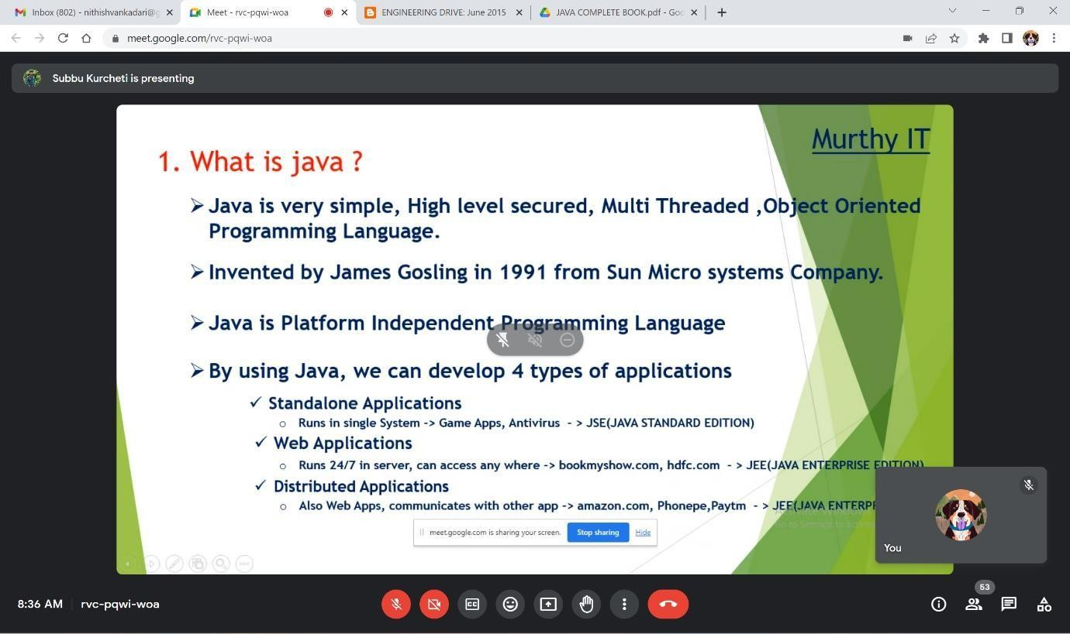

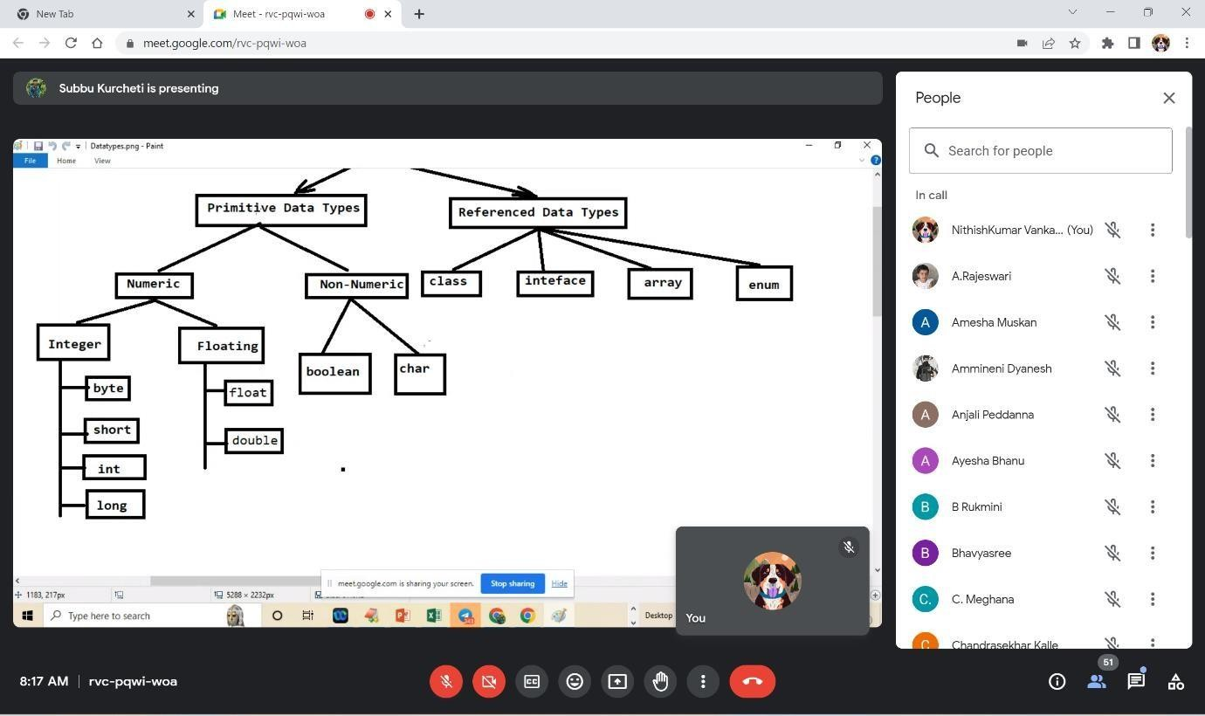

**Video Link:** https://drive.google.com/file/d/1LdbaMgqiOzKP4nHnlddckFRkYUHUQOab/view?usp=driv e_link

###### Week-2: Photos & Videos Links

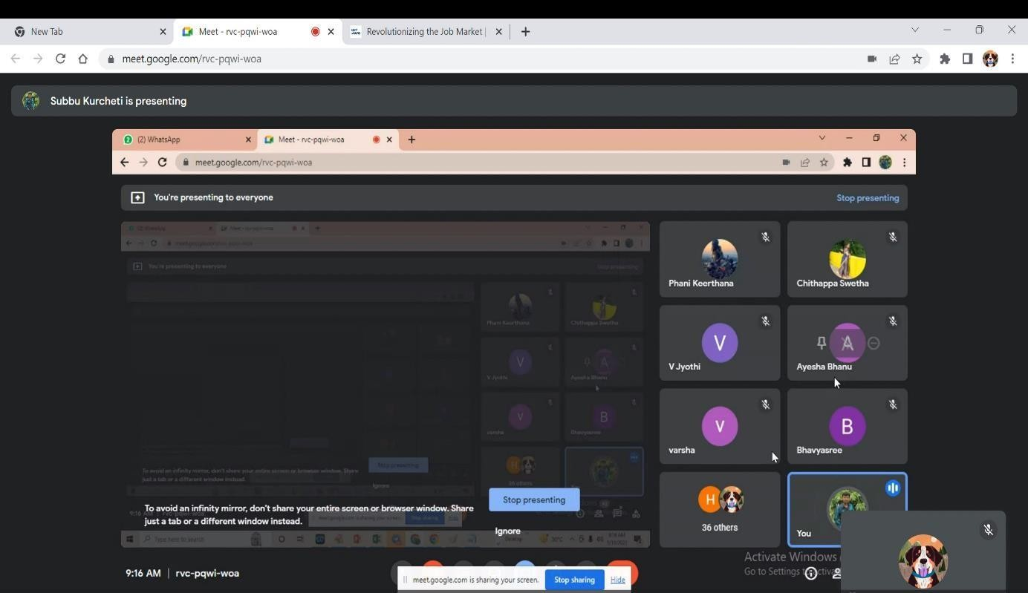

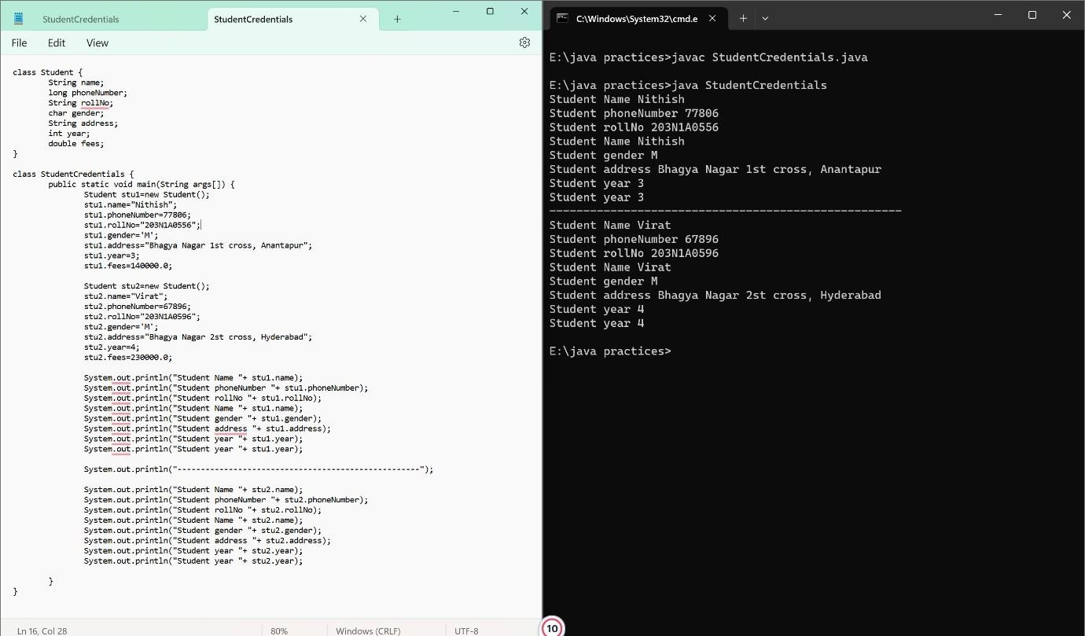

**Video Link:** https://drive.google.com/file/d/12Xwg8gwT89BUYaA00UHVErsoI3RJOzrm/view?usp=driv e_link

###### Week-3: Photos & Videos Links

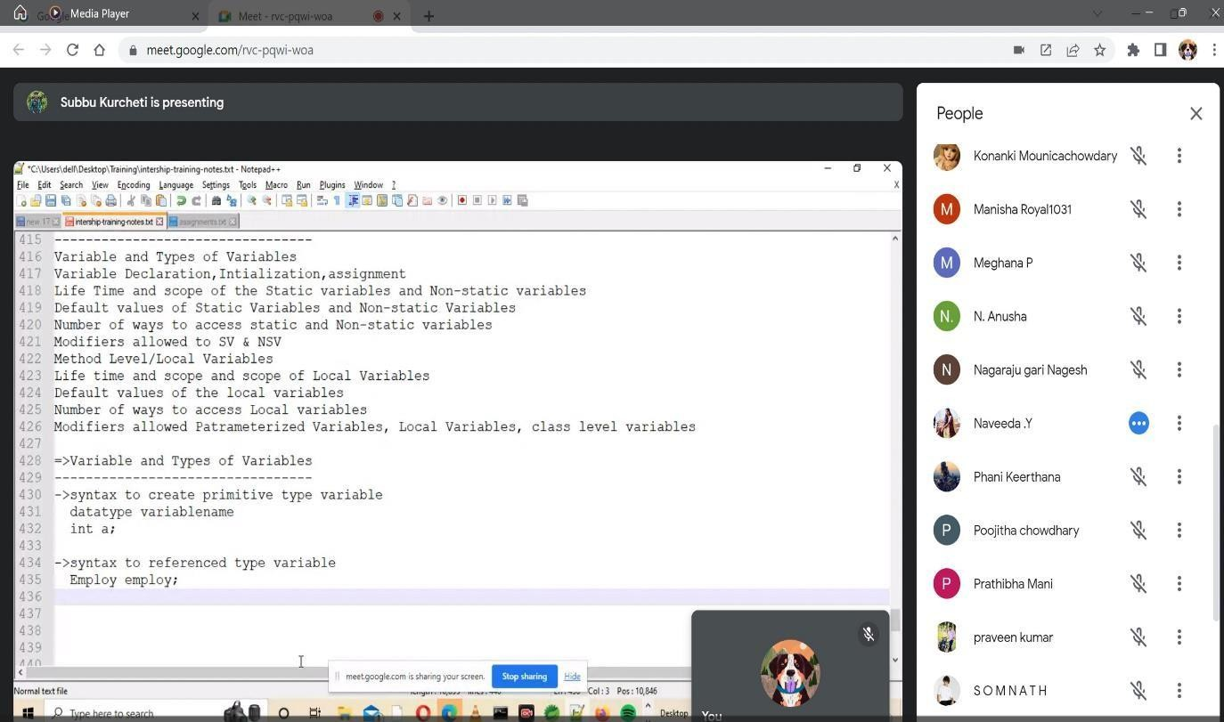

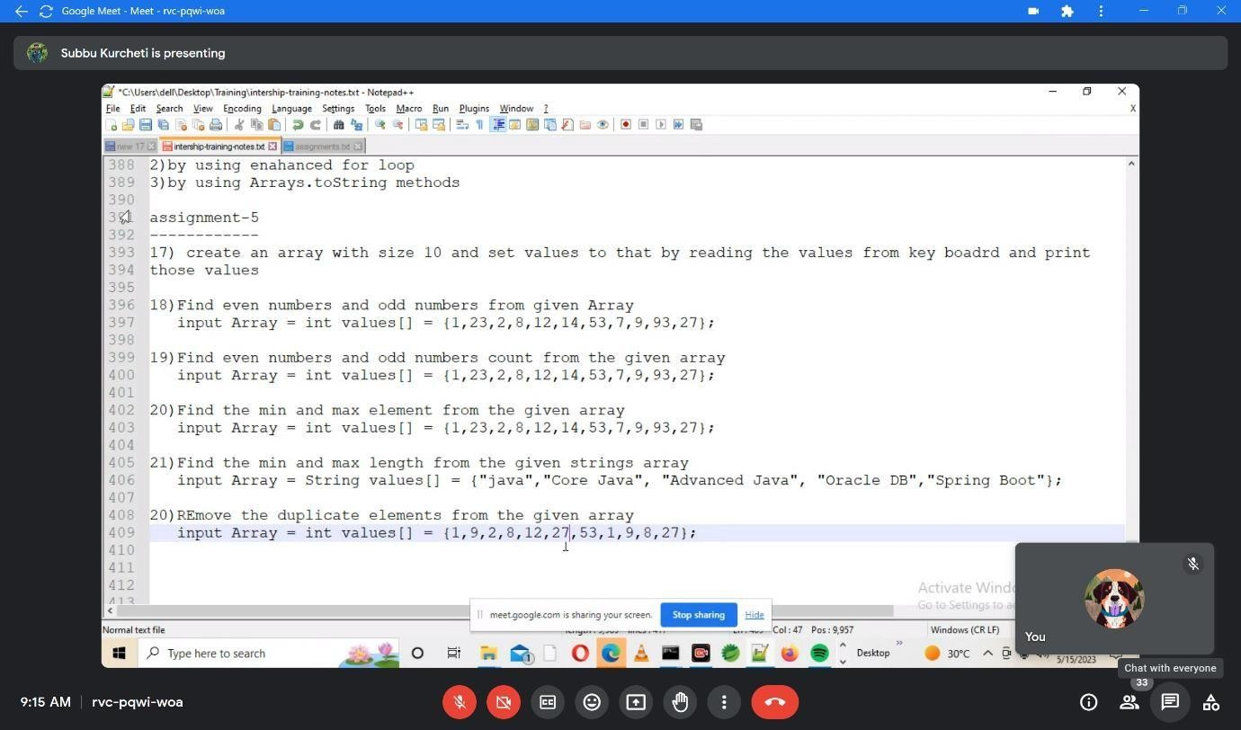

**Video Link:** [https://drive.google.com/file/d/1UzVIJZiMKcby_ZyLe70-cB0w-H-](https://drive.google.com/file/d/1UzVIJZiMKcby_ZyLe70-cB0w-H-UA3i4/view?usp=drive_link) [UA3i4/view?usp=drive_link](https://drive.google.com/file/d/1UzVIJZiMKcby_ZyLe70-cB0w-H-UA3i4/view?usp=drive_link)

###### Week-4: Photos & Videos Links

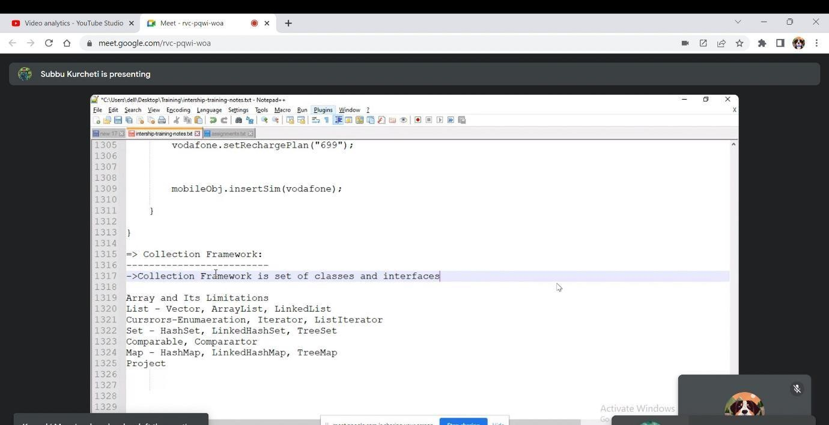

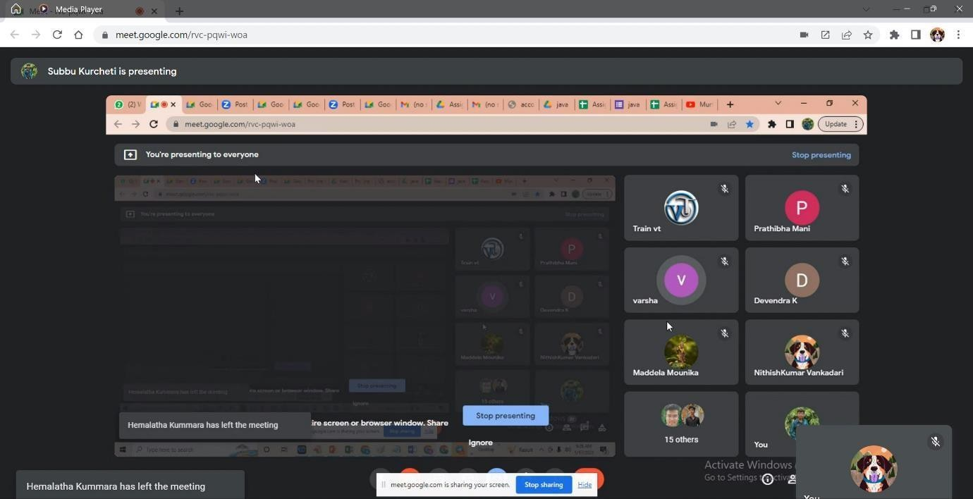

**Video Link:** https://drive.google.com/file/d/1qTnFDX74uvCtXlDdP3PirdTgJuGeN8jr/view?usp=drive_li nk

###### Week-5: Photos & Videos Links

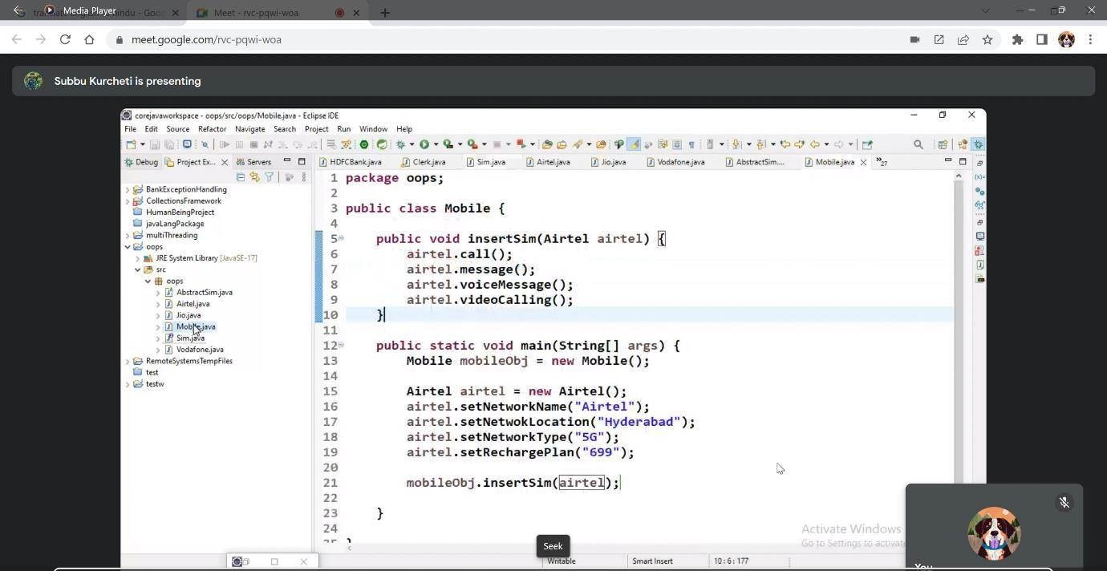

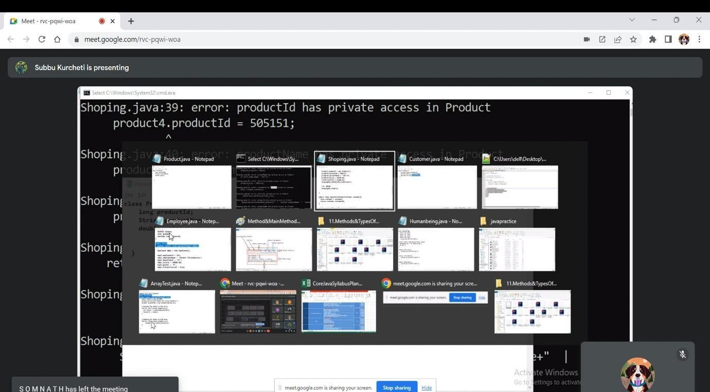

**Video Link:** https://drive.google.com/file/d/1XNxc7gebtg6cIDI4MC5n0F5KpLiTogKO/view?usp=drive_l ink

* 1. Week-6: Photos & Videos Links

